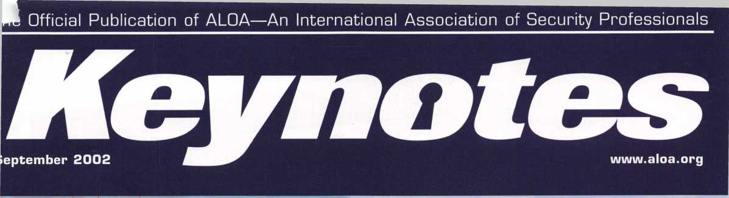

*I*

Today’s

(And H

ALOA 2002 Coverage Inside!!

on

}“H \

aru

CL

^ 51P

*So<

NO

#x «

* xt
* s:o2
* ota< *w _i
* ceciH- *caa.<

'ime Proble

YOU Can Help)

Plus/AmSec Round Doors,  
Medeo^/lJpdates for Key Wizard Software  
Transjaon'aer Secrets for Toyota and Lexus  
Bob Stafford. CML wins ALOA Award,

' / / and More

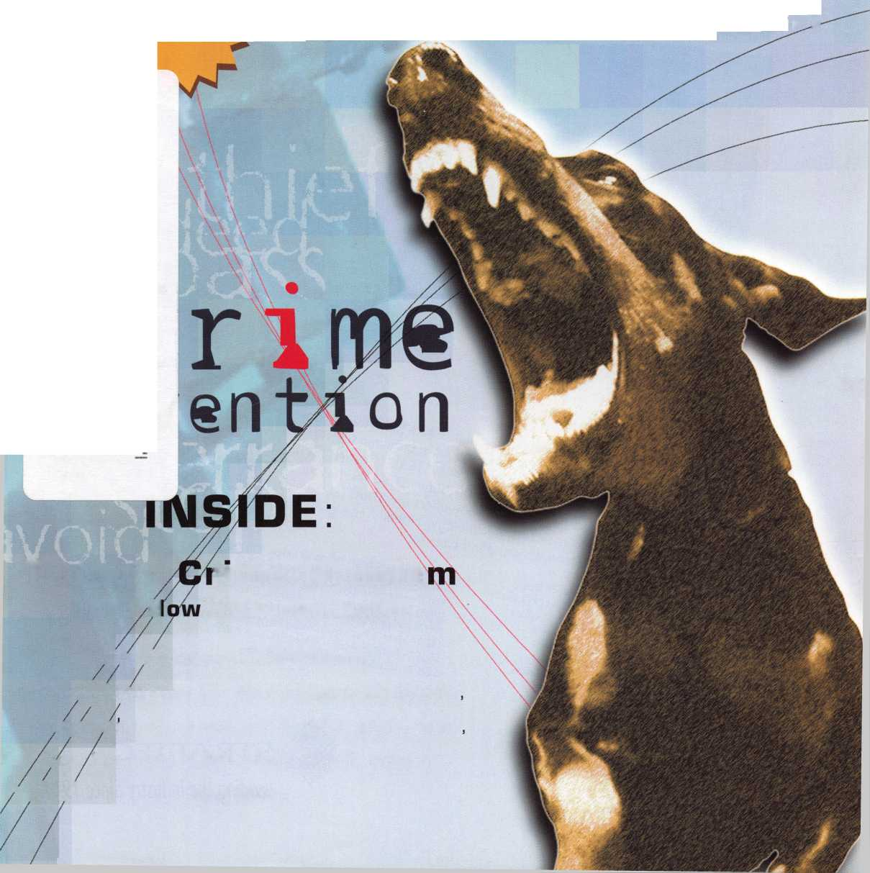

The Originals Stand Alone

®\u r

Only STRATTECcan supply the 2000 laurus and Sable transponder keys, along with other original Ford, DaimlerChrysler, GM, and Mitsubishi models. Only STRATTEC is America's largest transponder key OE supplier. So only STRATTEC's keys hit the market the same time the new cars do. Alone among the competition, STRATTEC has the technological experience that comes with leadership. Nobody else offers the STRATTEC seminars that keep you up to date with the latest in security technology. Nobody else gives you that kind of support; the originals stand alone, so you don't have to.

690556 - General Motors Primary 88 Groove RFID Key

690554 - General Motors Valet 75 Groove RFID Key

59833S - Ford Primary Molded 82 Groove PATS Key

599902 - Ford Primary Molded Encrypted 82 Groove PATS Key

599179 - Mercury Sable Primary Molded Encrypted 82 Groove PATS Key

599114 - Ford Taurus Primary Molded Encrypted 82 Groove PATS Key

598992 - Mitsubishi Primary Molded 90 Groove RFID Key

599479 - Mitsubishi Valet 89 Groove RFID Key

599452 - Chrysler RFID Valet Key 89 Groove 690222 - Chrysler RFID Primary Key 84 Groove 690224 - Chrysler RFID Valet Key 85 Groove 690226 - Chrysler RFID Key 90 Groove 599450 - Dodge RFID Key 90 Groove 599455 - Dodge RFID Key 84 Groove 690504 - jeep RFID Master Key 84 Groove 690225 - Neon RFID Key 84 Groove 690552 - General Motors 75 Groove RFID Key

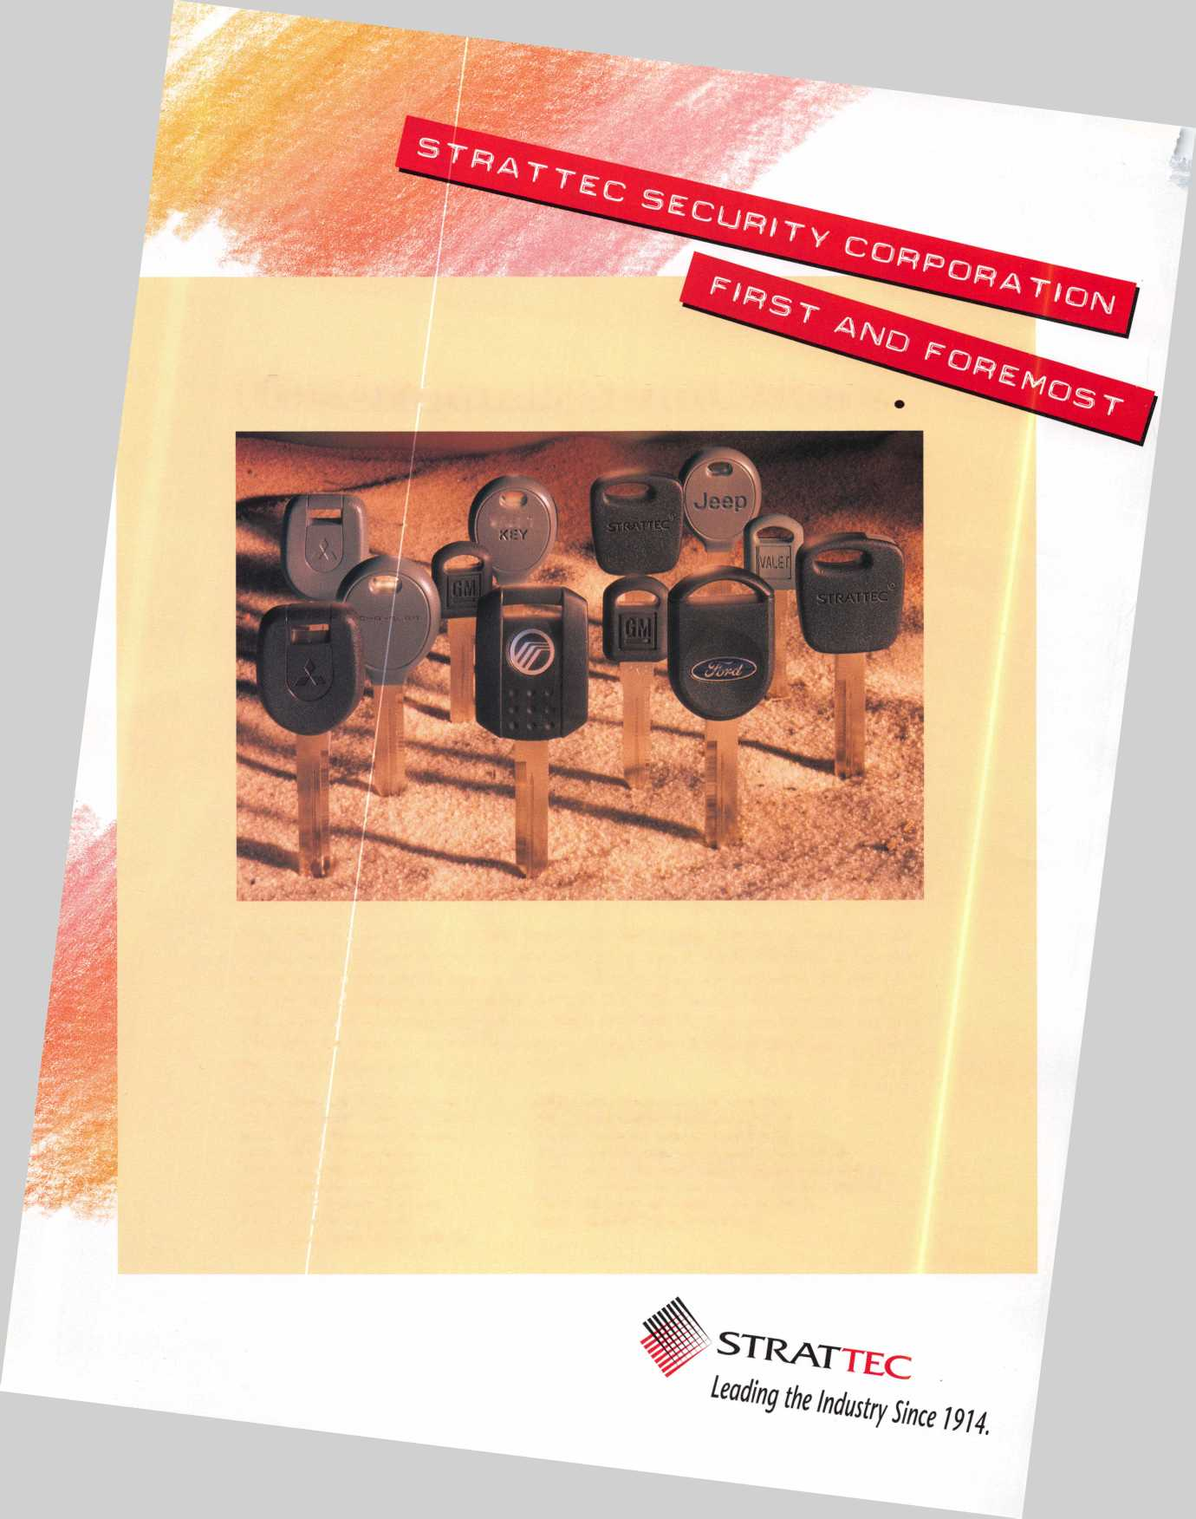

Keep Your Day Job

Come to Las Vegas and invest in your future.

Discover classes, workshops, and exhibits that will keep you competitive in today’s marketplace.  
Las Vegas Hilton/Las Vegas Convention Center • July 14-20, 2003

LAS VEGAS, NEVADA

ALOA 2003

♦ ♦ » **i**

The only gamble is staying home.

COVER

features



**16**

Our Kind of Town: ALOA 2002 Packs a Wallop By Jim DeSimone

Thousands of hours of instruction for students. Thousands of new products for curious lock­smiths. Great food, friends and fun. Not to mention the thousands in free giveaways and cash collected for locksmith scholarships. ALOA 2002 was one to remember.

Today's Crime Prevention Problem

(and How YOU Can Help) By Jim DeSimone

In the wake of the Sept. 1 1 terrorist attacks, we've redefined our view of security at home. This year's crime prevention month provides locksmiths with an important opportunity to make positive changes in their communities.

SAFES

20

AMSEC Round Doors.

By Greg Perry, CML, CPS

Take a look at the round combination lock doors produced by AMSEC/Major Safe, the STAR round doors, which have been produced in several different versions and sizes over the years.

INSTITUTIONAL



"Speechless" Stafford takes home the

ALOA Lifetime of Outstanding Achievement Award. By Jim DeSimone

One of the country's most distinguished institutional locksmiths just won ALOA's highest honor at the ALOA 2002 convention.

ACCESS CONTROL

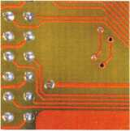

**30**

Medeco's KeyWizard Update By Gordon Malczewski

Medeco's KeyWizard Key Management Software has undergone a facelift, of sorts. Check out the new features with this primer.

AUTOMOTIVE

Transponder Secrets: Toyota and Lexus By Bill Neff, cml

Get some critical tips on how to make transponder jobs on Toyota and Lexus go quickly and smoothly.

**34**



Executive 3 Applicants 8 Legislative Classifieds 40 BackPage 44

Calendar 6 Core 10 Update 38 Associate

Members 42



Visit

our

w e

site at

WWW

aloa.org

Keynotes • September 2002



**executive**



Additional contact information for the ALOA Board and most Keynotes authors is available through "Locksmith Search'" on the ALOA Web site- [www.aloa.org](http://www.aloa.org) or by contacting the ALOA office at 3003 Live Oak Street; Dallas, TX 75204; (800)532-2562; FAX (214)827-1810; e-mail [aloa@aloa.org](mailto:aloa@aloa.org).

Editor

Jim DeSimone [editor@aloa.org](mailto:editor@aloa.org)

Technical Editor

David Lowell, CML, CMST [david@aloa.org](mailto:david@aloa.org)

Editorial Advisor

John D. Cannon, CML [jdcannon@worldnet.att.net](mailto:jdcannon@worldnet.att.net)

Art Director

Betty Henderson [betty@aloa.org](mailto:betty@aloa.org)

Graphic Designer

Rose Ellen DeSimone

PRP/Education Manager

David Lowell, CML, CMST [david@aloa.org](mailto:david@aloa.org)

Operations/Membership Manager

Mary May [mary@aloa.org](mailto:mary@aloa.org)

Director of Information Technology

Randy McChristian [randy@aloa.org](mailto:randy@aloa.org)

Government Affairs Manager/

Chapters & Regional Associations Liaison

Tim McMullen [tim@aloa.org](mailto:tim@aloa.org)

Comptroller Kathy J. Romo

Network Specialist Membership Coordinator Convention & Meetings Assistant PRP/Education Coordinator Accounting Coordinator Mail Room Coordinator

Advertising Sales

Kim Hammond

Executive Director

Charles W. Gibson, Jr., CAE

Contributors

Jerome Andrews, CML Paul Chandler, CRL Claire Cohen, CML Brian Costley, CML, CMST Ray D'Adamo, CML

voice: 817-645-6778

Fax: 817-645-7599 e-mail: [adsales@aloa.org](mailto:adsales@aloa.org)

.[charlie@aloa.org](mailto:charlie@aloa.org)

.[kelly@aloa.org](mailto:kelly@aloa.org)

Sal Dulcamaro, CML Billy Edwards, CML Dan Graffeo, CRL,CMST AJ. Hoffman, CML Jeff Nunberg, CML, CMST

Mike Oehlert, CPL, CPS Randy Simpson, CML Robert Stafford, CML Dave Thielen, CML Greg Perry, CML,CPS

... Greg Jackson

Shelly Jett

Karen Lyons

Ashley Manson

Kevin Wesley

Tom Seroogy Charles Stephenson, CPS Dennis Watanabe, CML, CMST

Convention & Meetings Manager

Kelly Carr, CMP

Mission Statement: The Associated Locksmiths of America, Inc. is dedicated to enhancing the professionalism, education and ethics among locksmiths and those in related sectors of the physical security industry. With approximately 10,000 members in the United States, Canada and the freeworld, ALOA is poised to help members obtain the knowledge, the strength, and the confidence to perform their role in the physical security field with pride and dignity. But it is only through active involvement and participation that ALOA can fully achieve its potential—and can help members to achieve theirs.

Policies: Keynotes® is the official publication of the Associated Locksmiths of America, Inc. (ALOA). Keynotes® acts as a moderator without approving, disapproving, or guaranteeing the validity or accuracy of any data, claim, or opinion appearing under a byline or obtained or quoted from an acknowl­edged source. The opinions expressed by the authors do not necessarily reflect the official views of ALOA. Also, appearance of advertisements and new products or service information does not constitute an endorsement of products or services featured by the Association. The Association does not accept responsibility for the inaccuracy of any data, claim, or opinion appearing in this publication, due to typographical errors on the part of the authors, Association staff or its agents.

Editor's Note: This publication is designed to provide accurate and authoritative information in regard to the subject matter covered. It is provided and disseminated with the understanding that the publisher is not engaged in rendering legal or other professional services. If legal advice and other expert assistance is required, the services of a competent professional should be sought.

Authors7 Payment: Payment for eligible submissions to Keynotes will be based on the following criteria: topic, time spent and past contributions. Authors who regularly submit to Keynotes® are generally paid a higher rate. The latter is especially true of authors who write to fit specific editorial needs and submit said copy by Keynotes® deadlines. As a general guideline: Average payment for a 750 word, business or light' technical article would be $200. Payment for a 1500 word article involving significantly higher time and research efforts would be $400.

Payment will not be offered for articles submitted by ALOA employees or members of the ALOA Board of Directors (unless material is of a technical nature), nor for articles submitted by a company that promote that company's products or services. ALOA reserves the right not to pay for articles sub­mitted by an individual(s) that promote a particular company's products or services.

Disclaimer: The Associated Locksmiths of America, Inc., (ALOA), reserves the right to refuse any article for any reason. Additionally, ALOA reserves the right to edit, amend or modify any article submitted for publication in order to preserve technical accuracy, clarity, fairness or grammatical cor­rectness. ALOA will make the best efforts to notify the author of any changes. The extent of ALOA's liability for any article or information contained therein will be a notice of correction or retraction in the next possible issue.

Keynotes® [ISSN 0277 0792) is published monthly except for the combined June/July issue by The Associated Locksmiths of America, Inc., 3003 Live Oak St., Dallas, TX 75204-6186. Telephone: (214) 827-1701; FAX (214) 827-1810; e-mail [aloa@aloa.org](mailto:aloa@aloa.org). Subscription rates for members—$15.00 per year. Second class postage paid at Dallas, Texas. POSTMASTER: Send address changes to: Keynotes, 3003 Live Oak St., Dallas, TX 75204-6186. © Copyright 1999, All rights reserved. No part of the contents may be reproduced or reprinted in any form without prior written permission of the publisher.

President

■ Randy Simpson, CML

(713) 780-7026  
[presidenf@aloa.org](mailto:presidenf@aloa.org)

Secretary

John D. Cannon, CML  
(703) 960-6413  
[secretary@aloa.org](mailto:secretary@aloa.org)

Directors, Northeast

John C. Magee, III  
(856) 845-3434  
[nedirector@aloa.org](mailto:nedirector@aloa.org)

Peter Sarailian, CRL  
(973)890-9797  
nedirector@aloa .org

(610)647-5042

. [nedirector@aloa.org](mailto:nedirector@aloa.org)

Directors, Southeast

Vincent Formon, CML, CPS  
(901) 324-2910  
[sedirector@aloa.org](mailto:sedirector@aloa.org)

. Donald E. Rul<§, CML  
(662) 324-2658  
[sedirector@aloa.org](mailto:sedirector@aloa.org)

Directors, North Central

Mark E. Blum, CML, CPS  
(517) 482-5809  
[ncdirector@aloa.org](mailto:ncdirector@aloa.org)

John Soderland, CML, CMST  
(414) 327-5625  
[ncdirecfor@aloa.org](mailto:ncdirecfor@aloa.org)

Director, South Central

Randy L. Simpson, CML

1. 780-7026 [president@aloa.org](mailto:president@aloa.org)

Directors, Southwest

Gordon R. Racine, CML (719) 384-4707 11 swdirector@aioa .org

Julie McCtuney, CRL

1. 636-5652 [swdirector@aloa.org](mailto:swdirector@aloa.org)

Director, Northwest

Scott L. Henke, CRL, CPS  
(907) 248-3785  
[nwdirecfor@aloa.org](mailto:nwdirecfor@aloa.org)

Director, Associate Members

David F. Matfhies  
(727) 541-5536  
[asdirector@aioa.org](mailto:asdirector@aioa.org)

Trustees

[trustees@aloa.org](mailto:trustees@aloa.org)

John J. Greenan, CML, CFS  
(773) 486.2030

Dallas Brooks  
(334) 826-8990

David M. Lowell, CML, CMST  
(800) 532-2562  
Edwin Toepfer, RL

Past Presidents

1999-2001 John Greenan, CML, CPS  
1997-1999 Dallas C. Brooks  
1995-1997 David Lowell, CML, CMST  
1993-1995 Breck Camp, CML  
1991-1993 Henry Printz, CML  
1989-1991 Evelyn Wersonick, CML, CPS  
1987-1989 Leonard Passarello, CPL  
1985-1987 Joe Jackman, CML  
1983-1985 Stanley Haney, CPL  
1981-1983 Louis LaGreco, CPL  
1979-1981 John Kerr, RL  
1977-1979 Clifford Cox, CML  
1974-1977 Charles Hetherington  
1972-1974 Gene Laughridge  
1970-1972 William Dutcher, RL  
1968-1970 Constant Maffey, RL  
1966-1968 Harold Edelstein, RL  
1964-1966 William Meacnam  
1962-1964 Robert Racldiffe, CPL  
19601962 Edwin Toepfer, RL  
1956-1960 Ernest Johannesen



Keynotes • September 2002

**president**

**journey**

**i**

s

Hello Members,

Next month is Crime Prevention month, and we're featuring crime prevention now to give you a chance to put together a program for the upcoming month. Somehow, it seems, Mcgruff the Crime Dog doesn't seem to have quite the bite he used to have. Since 9/11, the idea of terrorists has put crime into a different light. It leaves us looking at some differ­ent forms of security. Physical security alone may not be enough to combat this menace.

Our newest buzzword is Homeland Security. Our government wants us to know they are working on making us safe at home. They have committed resources and monies to thwart any schemes against us.

Once taboo (in Locksmith terms), surveillance and detection devices are more valuable tools to create a complete security package. Redundant security is the idea of causing account­ability at several different points, the bank vault being the last stronghold to defeat. Hope­fully, the guards are already notified and are watching the bad guys on the cameras.

Events cause changes. Dodge uses the phrase in advertising "This changes everything." Feeling safe at home is our nation's utmost concern.

Randy Simpson, CML

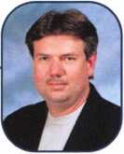

Keynotes • September 2002

Cruisin’ to Victory

Winner of the 2002 Van and Storefront Contest

487-3949'

**WOOD'S**

SERVICE

1-888-558-1884 *

"■* <35-7086 ,

fclALOAk,

Polish and professionalism were the name of the game as entrants put their vans on display for  
the contest. The winners were officially announced at the ALOA 2002 show in July. This  
year's winners enjoy a full convention package to the ALOA 2003 show in Las Vegas (over a  
$500 value). Take a look at the winners, and some of their worthy opponents.

3 **^** 336-7160* i

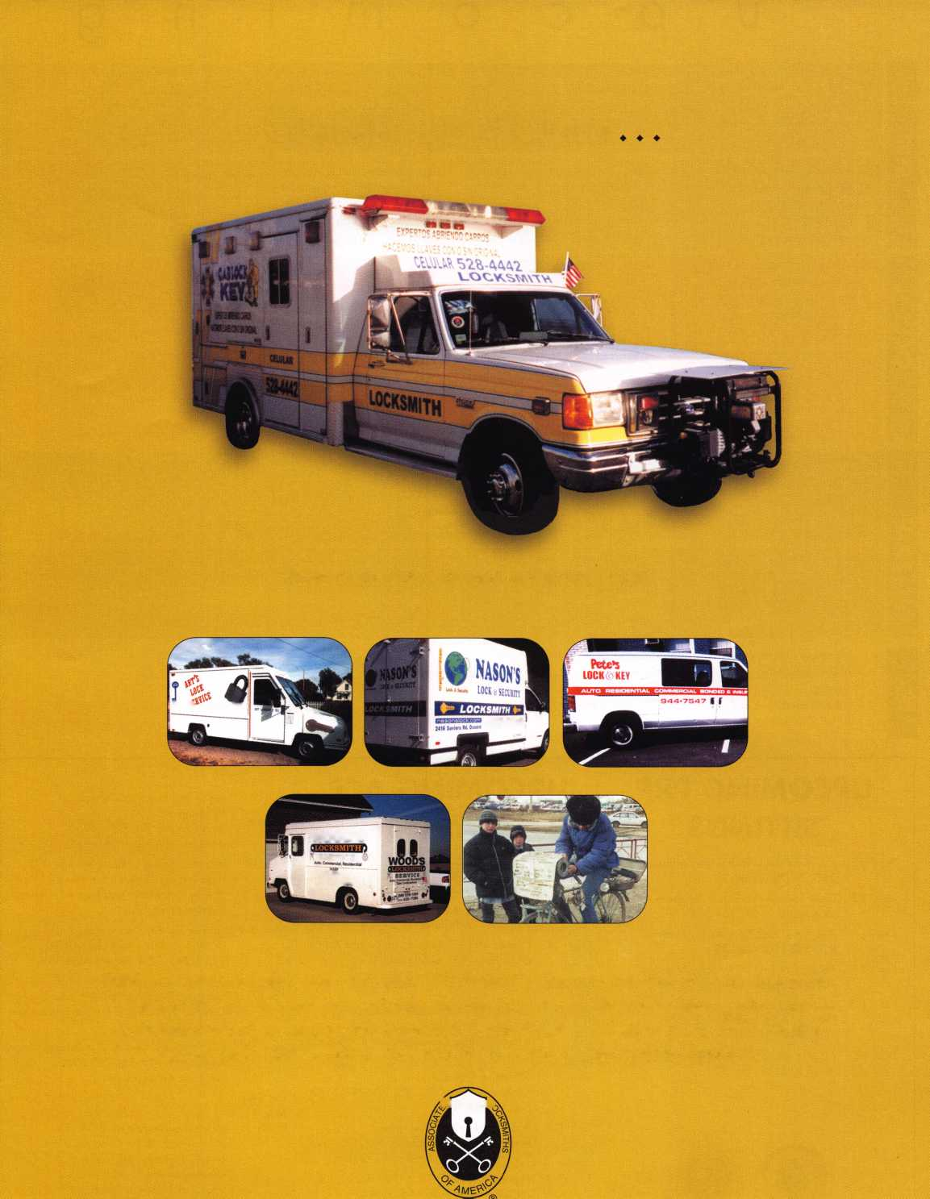

u

p

m

n

9

Minnesota Chapter of ALOA Membership Meeting Basic impressioning [www.locksmithnews.com](http://www.locksmithnews.com)

1 3-15 Wyoming Locksmith Assoc. Fall Meeting Casper Day's Inn 307-234-1159

14 Greater Houston Locksmith Assn. Auto Opening with Steve Young 979-323-9919 or [ditels@fbtc.net](mailto:ditels@fbtc.net) <http://ghla>. 1 cis.com/index.htm

14 Wisconsin Indianhead Chapter of ALOA Membership Meeting Kenneth Briggs 715-726-0687

25 Pacific Locksmith Association Membership Meeting 6:30pm Dan Cunningham 360-835-1191 [www.pla-pro.org](http://www.pla-pro.org)

25-29 SERLAC Trade Show Orlando, FL 800-845-529 [www.serlac.com](http://www.serlac.com) ACE • See Ad pg. 43

27-29 Jo-Van Distributors Inc.

2002 Annual Security Show and Educational Conference 416-752-2238 or 888-752-7210

7 Minnesota Chapter of ALOA Membership Meeting Basic Lock Cylinder Rekeying [www.locksmithnews.com](http://www.locksmithnews.com)

1-5 Pacific Locksmith Association Annual Convention Portland, OR 541-741-6902 [www.pla-pro.org](http://www.pla-pro.org)

Oregon Professional Locksmith Day Banquet

16 Central Florida Locksmith Assn. Membership Meeting 7:30pm Contact: Janet Boyer 386-775-3641



|  |  |
| --- | --- |
| 6 Minnesota Chapter of ALOA  Membership Meeting [www.locksmithnews.com](http://www.locksmithnews.com) | 6-10 Yankee Security Conference 9 Wisconsin Indianhead Chapter of 20 Central Florida Locksmith Assn.  Sturbridge, AAA ALOA • Membership Meeting Membership Meeting 7:30pm  Jack Hobin, CPL • 413-565-5152 Kenneth Briggs 715-726-0687 Contact: Janet Boyer  [www.yankeesecurity.org](http://www.yankeesecurity.org) 386-775-3641  See ad pg. 35 |
|  | 11 ;llll |

Minnesota Chapter of ALOA Membership Meeting

[www.locksmithnews.com](http://www.locksmithnews.com)

18

Central Florida Locksmith Assn. Membership Meeting 7:30pm • Janet Boyer 386-775-3641

**UPCOMING PRP  
SITTINGS**

**UPCOMING ACE  
CLASSES**

Oct.

14-19

Sept. 13 Sept. 22 Oct. 11 Nov. 8 Nov. 11

Dec. 13

ALOA • Dallas, TX • Ashley Manson: 800-532-2562, ext. 30

Clark Security Products • Anaheim, CA Joan Emrick: 619-718-7308

ALOA • Dallas, TX • Ashley Manson: 800-532-2562, ext. 30

ALOA • Dallas, TX • Ashley Manson: 800-532-2562, ext. 30

Crand Canyon Chapter of ALOA • Phoenix, AZ • John Ilk, CRL, CPS: 602-420-2174

ALOA • Dallas, TX • Ashley Manson: 800-532-2562, ext. 30



|  |  |  |
| --- | --- | --- |
| Sept. |  | Oct. 19 |
| 11-13 | Nutmeg Chapter of ALOA • Nutmeg, CT Dale Hobbs, CRL: 203-237-4602 |
|  |
| Sept. 14 | Gulfport, MS • Alabama Locksmiths Assn. Amanda Floyd: 334-793-5060 • 1 class | Nov. 6-9 |
| Sept. 14 | Casper, WY • Wyoming Locksmiths Assn. Gene Ficek, CPL • 605-642-4542  Domestic Auto Service & Update | Nov. |
| Sept.  21-22 | Central NY Locksmith Association | 16-17 |
|  | Syracuse, NY • Ronald Smith, CRL: 315-658-2368 Comprehensive 1C 1 & II | Nov. 23 |
| Sept.  25-27 | SERLAC • Orlando, FL  Michael Belden, CRL, CPS: 904-396-2022 | Feb 28 - |
|  | See Ad Page 43 | Mar. 1 |
| Oct. 1-4 | Pacific Locksmiths Association  Portland, OR • Karl Kretsch 541-926-3525 Fax: 541-334-1163 • See Ad Page 9 | 2003 |
| Oct. 9-11 | Nutmeg Chapter • CT • Dale Hobbs, CRL 203-237-4602 • See Ad pg. 44 |  |

Fox Valley Technical College Appleton, Wl

Jerry Antoon: 920-735-2406 [www.fvtc.edu](http://www.fvtc.edu) • See ad below

Northern Prairie Chapter • Fargo, ND Todd Ladwig, CML, CPS • 701-232-9440 Hollow Metal Door and Frame Servicing [todd@curtslock.com](mailto:todd@curtslock.com)

Yankee Security Convention Sturbridge, MA • Jack Hobin, CPL 413-565-5152 • See Ad Page 35

Georgia Chapter of ALOA • John Elliot Sr., CML, CPS Atlanta, GA • Comprehensive 1C I & II (2 days)

Alabama Locksmiths Assn. • Birmingham, AL Amanda Floyd • 334-793-5060 Electronic Safe Lock Svc.

Minnesota Chapter of ALOA Maplewood, MN • Dana Lee, CML 612-722-9181 •[H17@qwest.net](mailto:H17@qwest.net) Comprehensive 1C I & II (2 days) Servicing Aluminum Sotrefront Doors Life Safety Codes and ADA

**events**

|  |  |  |  |
| --- | --- | --- | --- |
| 15 Greater Houston Locksmith Assn. Free: Domestic Automotive  Lock Servicing Update with Steve Young • Ed Stites 979-323-9919 or [ditels@fbtc.net](mailto:ditels@fbtc.net) | 18 Central Florida Locksmith Assn. Membership Meeting 7:30pm Contact: Janet Boyer 386-775-3641 | 19 Florida West Coast Locksmith Association (FWCLA)  General Meeting  727-849-1812 | 21 Texas Locksmith Assn. Board Meeting • 9am-Finish  Tremont House Hotel  Galveston, TX [www.texaslocksmiths.org](http://www.texaslocksmiths.org) |
|  | | | |
| 23-27 Greater Philadelphia Locksmith Association (G-PLA) Convention | 25-26 South Carolina  Locksmith Assn. Meeting (803) 432-9009 | 26-27 California Locksmith Assoc. Convention and Membership Meeting • Town and Country Hotel • San Diego  Jack Lindstrom 760-364-4421 |  |
|  | | | |



**Locksmith Training**

Sponsored by Fox Valley Technical College • I 825 N. Bluemound Dr • Appleton, Wl 54912-2277

6-Day Program • Career Change in One Week • October 14-19, 2002

This is a basic locksmithing training course sponsored by FVTC’s Security and Crime Prevention  
Department and conducted by ALOA ACE instructors. Designed for the locksmith shop owner  
who would like to provide entry-level training for new apprentice locksmiths as well as those who

would like to receive professional training that will enable employment with a professional locksmith. The course will allow the student  
to gain enough knowledge to make them a starting apprentice in an existing shop. Job placement locations will be made available at the  
time of the class.

To maintain quality the course enrollment will be capped at 12 students. Enroll early!



Curriculum includes:

Key Blank Identification and Duplication Key Codes and Code Equipment Basic Master Keying

Lockset Servicing, Functions, Finishes

Life Safety Codes

Lock Pick Opening Techniques

Pin and Disc Cylinder Servicing Key Impressioning

Lock By-Pass Techniques Exit Hardware

Door Closers

Lockset Installation

Cabinet, Furniture, Mailbox Locks

All tools and equipment will be made available for use during training. Class Hours: 8:30 am to 5:00 pm every day Class Attire: Shop clothes Course Tuition: $995.00

Course Enrollment: See Susan Egnoski in the Criminal Justice Center

or call 920-831-4393

Note: Enrollment deadline is Friday, September 20, 2002

*<€>*

AR

KS

OR

I

When Failure Is Not An Option.

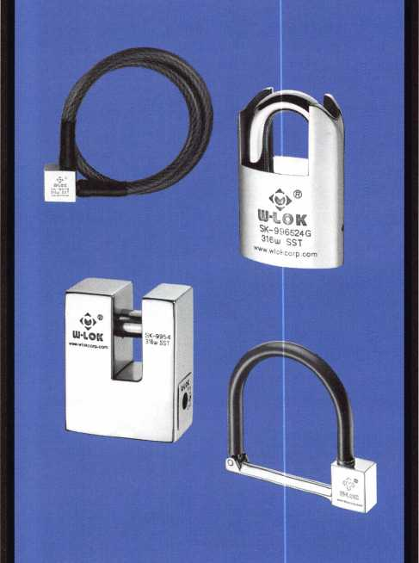

100% Stainless Steel • 100 Year Mechanical Warranty

Patent Cnntrolled Keying • Guaranteed Gnique Codes

|

Specially Hardened Cylinder  
Resistant to Environmental Conditions

> lll-LOK. And Stay Out.

**877.355.WI0K [www.wlokcorp.com](http://www.wlokcorp.com)**

Rogers

Corey Wright

Mesa

Bernadine Smith

Sponsor: William Lee

Fredrick E. Smith

Sponsor: William Lee Phoenix

Anthony Piazza

Sponsor: William Lee

*CA*

Vallejo

Robert W. Fowler

Sponsor: Carl A. Fowler RL

CT

Ledyard

Jon W. Hutchinson

FL

Miami

Lawrence

Charles E. Cudmore

Sponsor: Lee Pahcoddy Jr

MA

Belmont

Kevin Young

Sponsor: Michael A. Minghella CPL

MD

Olney

Peter I. Cordaro

Ml

Coldwater

Alexander Bielawski CJ Bielawski

Riverview

Jim Overbeck

Warren

David J. Serwatka

Sponsor: Ben Heath CRL

MN

Douglas H. Jones

Sponsor: Robert W. Duman Sr; CML

IA

Atlantic

Terrill L. Perkins

IL

Chicago

Dexter M. Tracey Getulio Ortiz

Evanston

Robert Perry

Libertyville

Robert L. Commons

Peoria

Thomas Randall

Sponsor: Robert T. Doran CML Rock Island

Christopher A. Moreno

Rockdale

Stephen T. Chamblee

Sponsor: David J. Braun Skokie

Kevin E. Guertin

Sponsor: Les H. Kutchins CPL Tin ley Park

James D. McFall

IN

Indianapolis

Steven L. Miller Schererville

Brian Van Denburgh

Braham

Michael Guderjohn

Marshall

Darin Veldhuisen

Sponsor: Dennis R. Velhuisen

MO

Arnold

Philip J. Falconnier

Sponsor: Ronald Schwartz

MS

Biloxi

Jason Necaise

Sponsor: Donald E. Necaise Jr

NJ

Florham Park

Matt Blaze

NM

Albuquerque

Phillip B. Morales

Sponsor: William A. Fadgen Jr,; CRL

E Rochester

Kenneth E. PerssonSponsor: Robert G. Sieveking

OH

Mentor

Lonnie Blakeslee

OK

Blanchard

Don Tiffin

Newberg

Alan Thurston

Bangor

Gilbert F. Walter CRL

Ellwood City

Brian Franksain

Malvern

Chris A. Strauss

Oil City

Richard D. Whitling Jr

TN

Lenoir City Kris Karnoupakis

Sponsor: Robb C. Isbell Van leer

Jim Cummings

Sponsor: Robert J. Jacko

TX

Austin

David Johnson Commerce William Alford CRL Port Arthur Joey A. Boudreaux Texas City Tyrene L Prall

UT

Clearfield

Mark Barnes

VA

Fairfax

John Mayers

Richmond Jeremy Ramsey

Sponsor: Calvin G. Harris CML

Wl

Green Bay

James M. Majeski

Sponsor: Larry R. Zochert

Christopher M. Martin

Sponsor: Larry R. Zochert Madison

Luke T. Geithman

Canada

ON-Concord

Suzanne Stieglmayr



Singapore

Lee Hon Wai

Fence

Teo Yew Chye

South Africa

WP-Cape Town

Kenneth O'Rourke

These applicants are scheduled for clearance as members of ALOA. The names are published for member review and comment within 30 days of this Keynotes issue date, respectively, to ensure  
applicants meet standards of ALOA's Code of Ethics. Protests, if any, should be addressed to the Membership Department and must be signed. Active Membership applicants (a) have worked in  
the industry two or more years. Allied Membership (AL) applicants are not locksmiths, but work in a security-related field. Apprentice Membership (AP) applicants have worked in the industry

less than two years.

Keynotes • September 2002

Plan Now

to Attend a Great Event!

2002 PACIFIC LOCKSMITH CONFERENCE

hosted by: PACIFIC LOCKSMITH ASSOCIATION

CLASSES • SEMINARS • CERTIFICATION • PRP TEST

Safe Classes-Opening, Servicing, Troubleshooting • Electronic Safe Lock Servicing • Domestic/Foreign Auto Update  
Aluminum Storefront Doors-Hollow Metal Doors • Exit Devices-Door Closers • Investigative Locksmithing I, II & III  
Master keying I & II • Impressioning • Access Control • Basic Electricity • Lock picking  
Basic Locksmithing • Surreptitious Lock Bypass Techniques  
**Some Classes are ALOA ACE Classes**

INSTRUCTORS

ALOA ACE Certified Class Instructors

Jerome Andrews,CML • Jim Bickers,CFL • Ray D'Adamo,CML • David Theilen,CML • Jim Watt, CML  
**Nationally Recognized Instructors in Specific Fields**Carl Doerr • Dave McOmie • D.W. Dowless ,CML,CMST* E. Lee Griggs

HOTEL INFORMATION

Holiday Inn at the Airport, 8439 N.E. Columbia Blvd, • Portland, OR 97220 • (503) 256-5000  
**Mention you are with the Pacific Locksmith Conference**

REGISTRATION INFORMATION

Dan Cunningham • Phone & FAX (360) 835-1191 • [danslocksafe@juno.com](mailto:danslocksafe@juno.com)

EXHIBITOR INFORMATION

Tom Jones • (503) 842-2944 • FAX (503) 842-5876 • [tjlock@oregoncoast.com](mailto:tjlock@oregoncoast.com)  
OR Karl Kretsch • (541) 926-3525

CHECK OUT OUR WEBSITE FOR MORE DETAILS • [WWW.PLA-PRO.ORG](http://WWW.PLA-PRO.ORG)



**rfx SEPT. 30 and OCT. 1-5, 2002 • TRADE SHOW OCTOBER 5th**

**at the HOLIDAY INN at the AIRPORT • PORTLAND, OREGON**

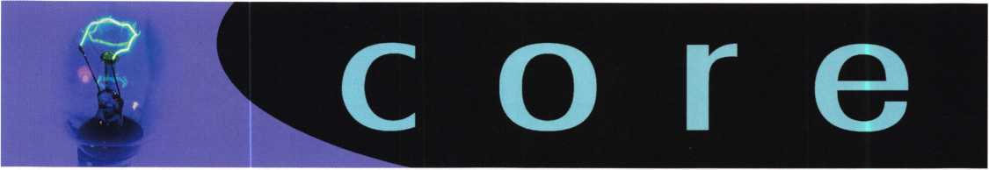

ALOA's POSITIVE ID POLICY:

ALOA locksmiths are instructed to use the following positive

identification policy when servicing lockouts:

* Notify Caller. When a call comes in to request lockout services, ask the caller if he/she has identification and authority to open the lock.
* Complete Form. Upon arrival at the job site, the lock­smith should complete an Authorization Form that asks for the name, address, phone number, identification number and property description from the customer.
* Verify I.D. Verify the customer's photo-identification card and compare it to the information provided by the cus­tomer. If no photo-ID card is available, ask for some other reasonable form of ID.
* Verify Authority. The locksmith should inquire as to what authority the customer has to open the lock, and request to see any reasonable and appropriate evidence that could verify the authority. This may be impossible in some cases.
* Ask for Signature. Ask the customer to sign the Authorization Form, which should contain a statement that (a) the information given by the customer is correct,

1. the customer has the authority to open the lock, and
2. the customer shall identify and hold harmless the lock­smith against liability.

* Optional Last Resort. If you have any suspicions that the customer is giving false information or does not have authority to open the lock, say that you will be happy to open the lock provided a law enforcement officer

is present. If the customer agrees, call the police; if not, leave.

* File the Form. Keep the Authorization Form on file for a reasonable period of time.

Need Help?

At ALOA, we want to make sure you are getting as much bang for your membership dues buck as we are able to give you. If you have had problems getting membership services, or have a question regarding member services, please con­tact Bill Gibson, executive director, at 800/532-2562, or e- mail: [charlie@aloa.org](mailto:charlie@aloa.org).

Let Us Know!

If you have an opinion to offer on ALOA, the state of the industry, or life in general, we want to know about it! Submissions to the "Mailbox" section of Keynotes are printed on a space-available basis. Write to: "Letters to the Editor"; ALOA; 3003 Live Oak Street; Dallas, TX, 75240; FAX 214/827-1810; e-mail: [editor@aloa.org](mailto:editor@aloa.org).

Letters

Dear ALOA,

I am writing to you today because of my father, Clayton E. Merry. My Dad passed away June 24, 2002; he was 95 years old. Dad and I were ALOA members for many years. Dad retired in 1988. Dad loved locksmithing, and helping people. Both of us owned C&J Locksmiths, Ft. Erie, Ontario, Canada, and M&M Locksmithing in Angola, NY. In his younger years, he went out on jobs. His older years were spent in the shops, doing what he loved to do - lock work. He was also a member of the Penn-Ohio Locksmiths Association. Locksmithing for my Dad was not just a busi­ness; he loved it.

Yours Truly, John M. Merry, his son

Note: On behalf of everyone at ALOA, we extend our sym­pathies to the Merry family.

New Certifications

CRLs

William Alford  
Robert Greathouse  
Terry Logan  
Jose Morales

Commerce, TX Concord, CA El Cajon, CA El Paso, TX

Keynotes • September 2002

**GATE**

Future

CHNOLOGY

**SAFE AND VAULT T**

**CONVENTION**

**MARCH**

24-29

**BAHIA RESORT HOTEL •**

**CHNICIANS ASSOCIATION**

**TRADE SHOW**

**SAN DIEGO, CALIFORNIA**

THE

SAFETE



in between.

about bang for your buck. The 2002 ALOA

Convention and Security Expo, held in the Chicago  
suburb of Rosemont, IL, in late July didn’t just have it

all - it had a lot of everything. From first timers to old  
timers, from big bucks to freebies, from workmen to

girls, the industry’s biggest and best show

somehow outdid itself again.

t started with a bang and just got better, as full day

classes started bright and early on

Monday July 22, 2002. Classes  
were taught by the industry’s best  
- ALOA ACE instructors - and

covered every security-related sub-

under the stars.

The menu of classes

offered to participants  
covered a little of  
everything, including  
topics from master

to aluminum

doors, to investigative

locksmithing to electronic  
access control, to financial

management, to ADA

**2**

Keynotes • September 2002

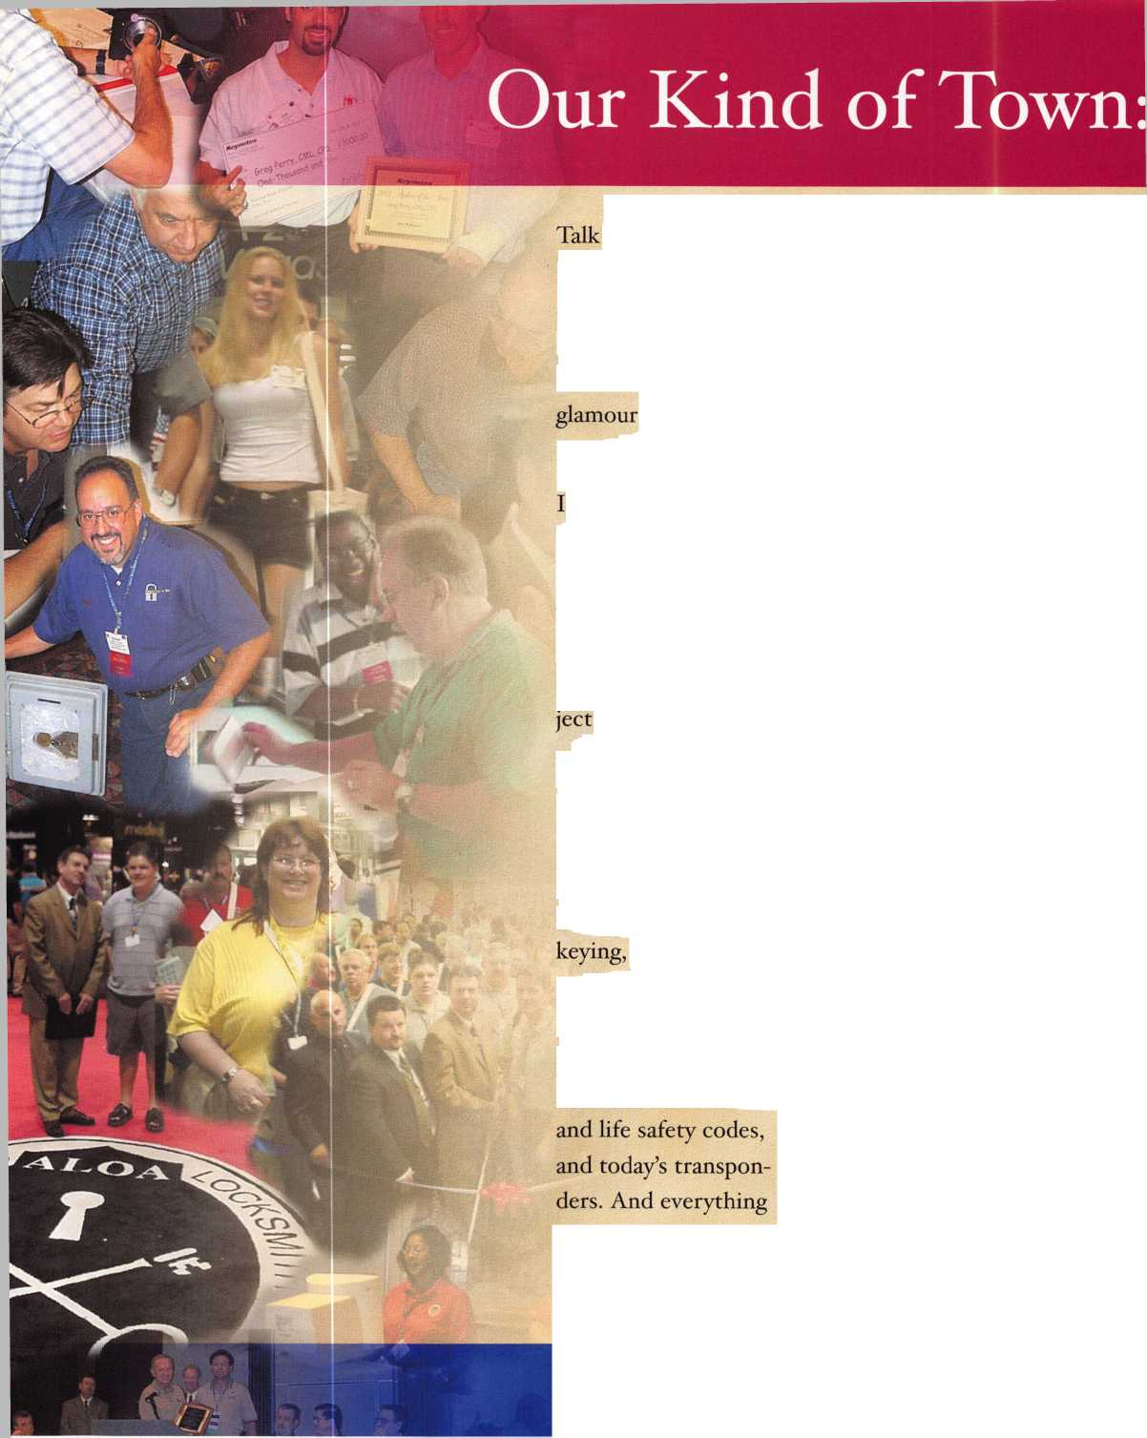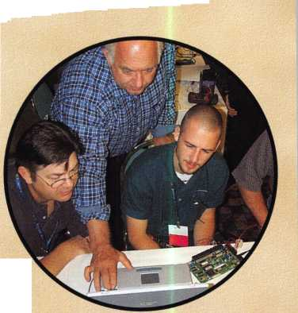

OA 2002 Show Packs a Wallop

The Hyatt Regency O’Hare facilities are among the region’s finest, with plen- A ty of local activities that took members on unforgettable trips through one of America’s great wg A cities. This year’s “Secure America” show stressed the sense W>m of heightened security in our y|H

country today in the wake of the ^ now infamous terrorist attacks of Sept, n, 2001. ALOA is calling on lock­smiths from around the world to m learn about new security con- /"JuPI cepts, how to install and service B, the best new products available, V and how to sell them to a public searching for protection in today’s dangerous world.

The ALOA show has come to represent an f . y

annual week of meeting friends new and Mmh'' old. Sharing in the camaraderie and pro- fessional interchange that occurs each year at our show is really the icing on the cake.

If you’ve never been, or haven’t been in a while, you owe it to yourself to see how our shows can pay off for you. There’s just no denying the knowledge available and the good times to be had through the simple interaction with professionals just like you who come to this show from around the world year after year.

Keynotes • September 2002

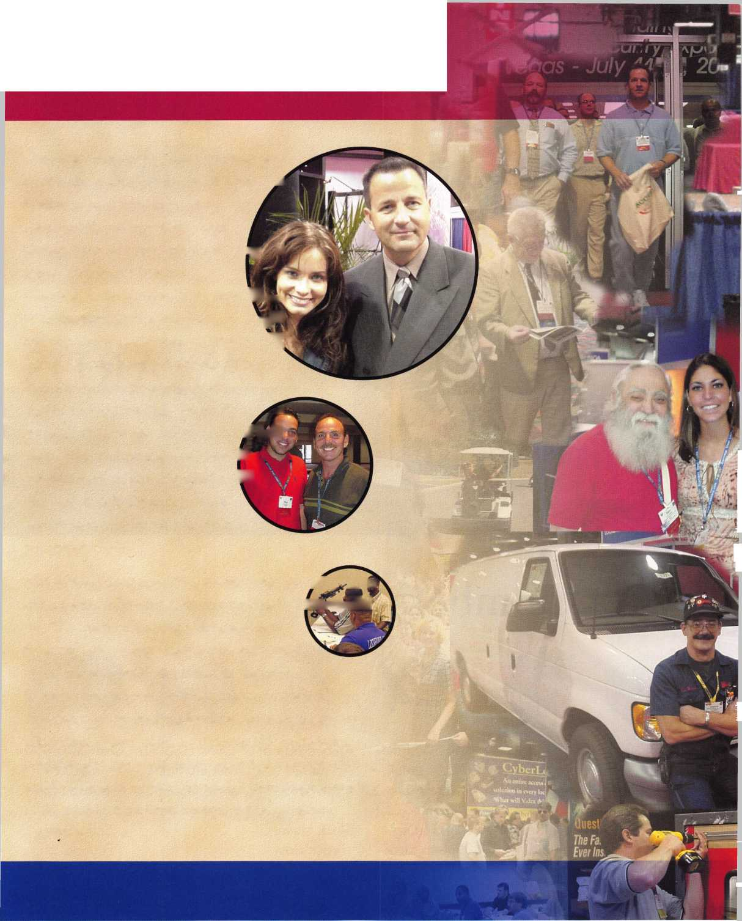

**ALOA Lifetime  
of Outstanding  
Achievement**

Bob Stafford, CML

**President's Award**

Lenny Passarello, CPL

**Keynotes**

**Author of the Year**

Greg Perry, CML, CPS

**Life Members**

Jerome Andrews, CML  
and Walt Lascar, RL

**ACE Award**

Ray D'Adamo, CML

By the numbers ...



Over 3,300 participants



1 11

international  
attendees from  
29 different  
countries all  
around the  
world.



All 50 of the  
U.S. states  
were repre-  
sented,  
including  
Puerto Rico.



An average of  
330  
students  
attending  
ACE classes  
each day.



Over 10,000  
student hours  
of professional  
instruction.

Over $30,000 raised by auction for the ALOA Scholarship Foundation.

Keynotes • September 2002

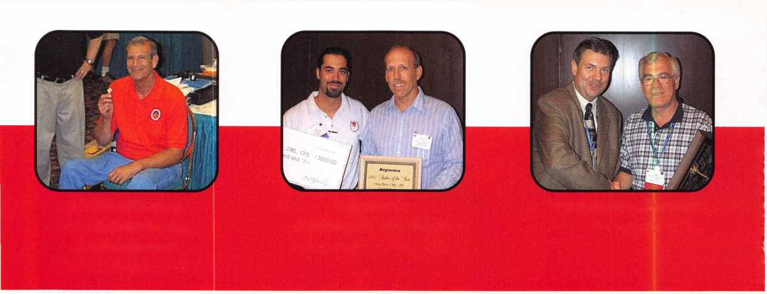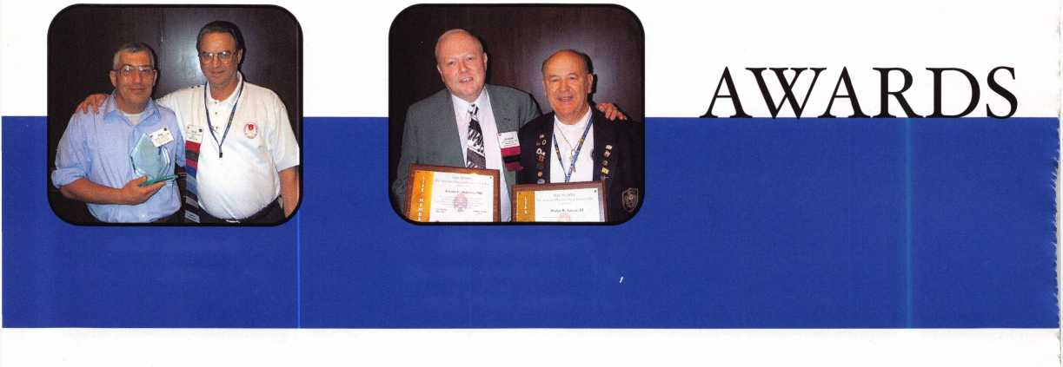

ALOA 2002 Convention Spotlight:

Stan Haney Award

When ALOA Past President Stan Haney founded the ALOA Scholarship Foundation some 20-???? years ago, he had no idea it could grow into what it is today.

“It started as just a group of guys getting together for meetings and just pitching in some money together,” he said from the ALOA 2002 show floor. “When we got the corporations behind the idea, the Foundation really took off.”

This year marked the birth of a new award - the ASF’s “Stan Haney Award,” which is now awarded annually to a deserving donor from around the industry The first award, fittingly, went to Tale Security Group for their tireless devotion to the cause of the ALOA Scholarship Foundation through the annual ALOA Open Golf Tournament.

“It’s such a great honor,” Haney said of their many years of sponsoring the award that holds his namesake, “I never thought I’d live long enough to have an award named after me.” Q .

Keynotes • September 2002

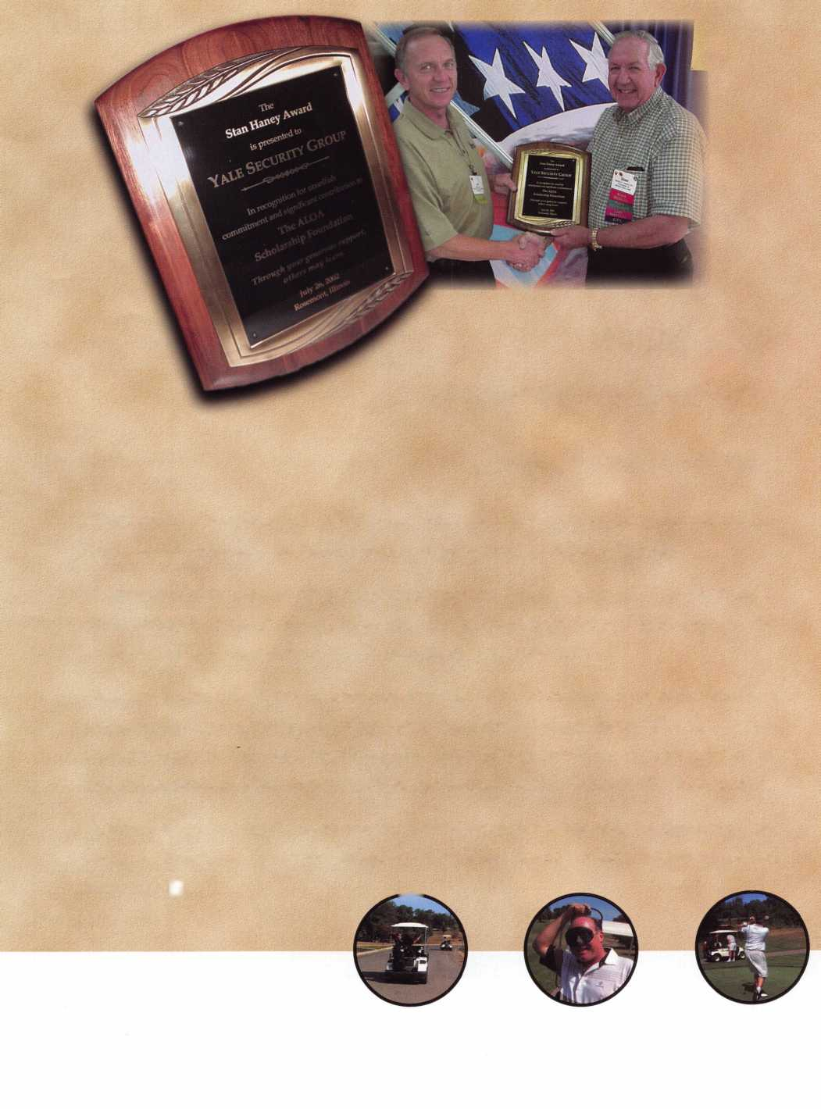

TODAY'S CRIME PROBLEM

(AND HOW

HELP)

to the National Crime Prevention Council,

is year’s crime numbers~suggest-an urgent need to

ention efforts. Statistics indicating that

reported crime is up are a reason to redouble crime

prevention efforts and to avoid falling into the  
trap that demographic and economic

conditions govern crime

rates, warned John

A. Calhoun,  
President and CEO of  
the National Crime

Prevention Council recently

’’With a healthy economy and  
low numbers of young people in the  
early 1990s, violent crime still  
rose,” Calhoun pointed out. He  
noted that communities that

are taking comprehensive,

locally grounded, coordinat-  
ed action to reduce causes  
of crime are still doing  
well compared with

their counterparts.

"The FBI’s prelimi-  
nary 2001 data tell us  
that reported crime is  
up, which may actually  
be a good thing. More  
reporting to police can  
mean that people feel  
more comfortable call-

**6**

Keynotes • September 2002



ing them," Calhoun said. "We have reduced crime to a 30-year low, and our challenge in sustaining and improving on that record is fivefold:

* Recognize that police alone cannot do the job - some of the lowest-crime communities also have low police-to-resident ratios.
* Involve all elements of the community - business, faith, schools, civic groups, neighborhoods, public health, and more - in collaborative, prevention- focused partnerships.
* Address causes, not just symptoms - for example, by providing after school programs that provide positive, attractive options for youth.
* Support and engage young people, through a vari­ety of mentoring and youth-led programs.
* Help strengthen families so that they can bring up their children to be safe, active, productive citi­zens of their communities.

"This strategy takes the long-term view of building healthy, strong communities in which families, chil­dren, and other residents can thrive," Calhoun contin­ued. "It works where there is local leadership and commitment to preventing, not just reacting to, crime problems."

Where You Come In

The NCPC says effective local crime prevention coalitions combine the energies of the community with local government authorities in a concentrated effort to address crime concerns. Such planning takes a great deal of teamwork and leadership, for it demands an acknowledgment that no one city agency or neighborhood can resolve the problems alone. It also means that local government departments must pull together with law enforcement and requires a willingness to involve all sectors of the community as equal partners. Despite the challenge, it can and does work. Local locksmiths willing to take the lead in

such efforts (and promote their businesses in the process) are the prime candidates to champion such an effort. It’s a great opportunity to get involved in your community and grow your business at the same time. And it happens all month long in October. Get on the phone and make it happen!

Be able to answer the basics when you kick off your efforts with those first few phone calls:

Why should local governments and communities form coalitions?

Because potential outcomes include improvements in:

* Quality of Life Community in which people want to live; restoration of community bonds
* Public Safety Residents who are determined to stop crime; reduced crime; reduced fear of crime; safer neighborhoods; safer public places; safer children
* Economy Enhanced tax base; healthier neighbor­hoods and local economies
* Citizen Well-BeingResidents engaged in solving community problems; stronger, healthier families; better climate for learning; more stable neighborhoods
* Government Capacity More effective use of city resources; cooperative problem-solving focus by local agencies; better information for decision­making

Who should be involved?

* Criminal Justice Police, sheriff, courts, prosecu­tion, parole and probation
* Human Resources Social services, labor, youth organizations, senior citizens' centers
* Education Schools, colleges, and universities
* Health, Safety, and Quality of Life Hospitals, public health systems, housing, code enforcement, sanitation, fire, recreation and parks, transportation

Keynotes • September 2002

* Connecting Resources Mass media, churches, foundations
* Fraternal, Civic, and Professional Associations Neighborhood groups, social and civic clubs (e.g., Lions, Jaycees, Kiwanis), profession­al societies
* Businesses Major corporations, small businesses, chamber of commerce
* Special Populations Senior citizens, teens, newly arrived populations

Developing a Plan

NCPC directives show that the major decisions in mak­ing a crime prevention plan for your neighborhood are:

* Functions and Purpose: Generic functions, issue scope
* Organization and Structure: Roles and topics, responsibilities, relationships, decision making
* Participants: Membership, role of public, role of community groups
* Process: Intensity, nature, coordination, problem definition and needs assessment
* Product: Plan, implementation, other
* Timetable: Publication of plan, implementation, immediate action

Major elements in a plan

* Recruit community/agency partners
* Create a vision
* Assess community issues and priorities
* Decide on structure and form task forces
* Formulate goals and objectives
* Set success measures, how to track them
* Develop a comprehensive strategy to address priorities along a timeline
* Identify resources needed and secure them
* Recognize partners’ contributions
* Implement the strategy
* Evaluate the impact of the strategy
* Revise objectives, success measures, and strategy as necessary

What makes a solid action plan

* Clear commitment of top leaders to the idea and process
* Forethought on group member structure, roles and responsibilities, timelines, resources for support, and expectations
* Consensus about the major problems that must be confronted
* Orientation and planning that build teamwork and momentum
* Anticipation of and building of public support for the plan
* Involvement of sufficiently wide range of sectors as well as personalities, interests, and disciplines to help ensure recommendations to get support
* Ample opportunity for planning group to learn, to develop own style and decision/consensus processes
* Thinking about issues in the widest possible sense
* Leveraging short-term recommendations to gener­ate momentum
* Recognition
* Stable staff support
* Relatively nonpartisan context

Now that you have a plan in place, how do you sustain

your efforts and ensure success?

Ensuring Success in Crime Prevention Projects

What are the key principles for success?

* Prevention, not only enforcement
* Police as partners
* Formal and informal leaders
* Mobilization of all sectors
* Addressing both perceptions and realities
* Starting with a clean slate
* Sharing a vision
* Including long-term as well as short-term actions
* Developing an institutional base
* Recognizing that the process is the secret

I

**8**

Keynotes • September 2002

What does it take to sustain progress?

* Support from top political leaders
* A balance between prevention and enforcement
* A process that remains open to community participation
* Other agencies working with police
* Staff with authority to keep process moving and enforce commitments
* Involvement of many community sectors
* Structure flexible to evolving needs
* Clear information on qualitative and quantitative measures of success
* Training and leadership opportunities for neighborhood partners
* Resources from a variety of public and private sources
* Positive coverage and community feedback

Find out more about the specific planning models, tactics, and crime prevention strategies that over 30 localities have applied to local priorities and how NCPC can help you with your community initiative.

How NCPC Can Help You!

Many cities and towns have struggled to identify problems, appreciate assets, and implement strategies. Some communities have taken small, incremental steps. Others have been more comprehensive and bold. The National Crime Prevention Council (NCPC) can help you learn from their trials and errors -- and success. Having worked for many years on local crime and vio­lence prevention initiatives, NCPC can provide your community with critical material resources, training, and guidance about how to develop a comprehensive local crime prevention and control strategy through a community-local government planning coalition.

We can meet your individual training and coalition development needs by bringing field-tested curricula on comprehensive local planning to your city. NCPC train­ings typically last two to three days. Costs, which range from $7,ooo-$9,ooo, cover resource materials for 75- 100 trainees as well as expenses for NCPC and field trainers. The curriculum can be tailored to meet your needs, including adjustments to the length of the train­ing and topics covered.

In addition, NCPC staff are available to support, through a technical assistance contract, the facilitation of local coalitions. Our staff have considerable experi­ence coaching and advising local initiatives, providing insight based on extensive field experience and expo­sure to successful strategies adapted by localities throughout the country.

For more information on how you can make a differ­ence next month, call the NCPC at 202/466-6272. Q

Po werMa te®

MOTORIZED STAIRCLIMBING HANDTRUCKS

Power Tailgate Lift Power Dock Leveller

Ord efc

Yours • Today!

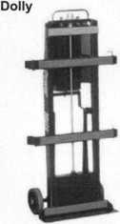

Many models to choose from:

**PowerMate M-1** 15001b. Capacity **40”+ Lift** **to** Tailgate

Built-in 4 Wheel

Power safes, ATMs, vault doors, etc. up/down stairs and on/off vehicles safely and quickly at the push of a button. Because PowerMate® does 100% of the lifting, there is no strain on your back or legs.

More secure handling results in less risk of damage to your productsand/orclient’sstairs,wallsandfloors,saving money!

1***-***800***-***697-6283

[www.lpinternational.com](http://www.lpinternational.com)



Keynotes • September 2002

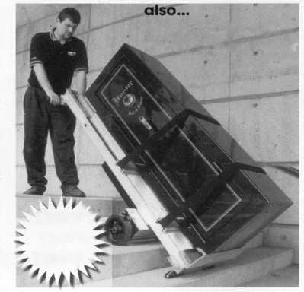

By Greg Perry, CML, CPS

Last month, we covered  
Major safe round doors. This

month

we re go

at other round c  
lock doors produ  
AMSEC/Major Sal  
round doors. These c  
been produced over the  
eral different versions ar  
7 1/2-inch diameter lift c  
the most common and i:  
them a “C L/O” door, me  
rate Lift-Out door. It is also  
“E” rate lift out “E L/O.” A larger 9 1/2-inch  
door was produced, model number “CL L/O”  
rate Large Lift-Out door. In addition to the 1

doors

a tapered hinged door was available in

“C” and “E” ratings. The difference between  
is steel thickness. “C” rates have a minimum  
front of the lock with a 1/2-inch steel body. “

Keynotes • September 2002



J| out at 4 or 17; this will  
W allow you to view the  
! wheel pack though the  
bolt cam, then transfer  
k to 11 to open the safe,  
id when working on these

The original round door seen in photos 1 through

4 was produced in Compton, CA, by the STAR SAFE Company starting about 1947 prior to the company becoming American Security Products and moving to Industry CA then Irwindale, CA, and finally their present location (since 1987) in Fontana, CA. It uses a 1 9/16-inch diameter die cast mesh change wheel pack. This particular door was manufactured in the 1950s. It has a blue-green hammer tone finish. Serial numbers on these doors went up to 22088. Opening this safe is best accomplished by manipulation. The drive cam is the same diameter as the wheel, the contact points are at about 10 and 14. If your manipulation skills fail you and it’s time to drill, the drop-in is at 11, but this is a bad location to drill. A bolt is in the way and the drive cam is not open at this loca­tion. A much better location is to drill 3/4-inch

fragile and will break if mishandled; sometimes they will even if you are careful

The next door pictured in photos 5 through 7 is the tapered ^

The serial these doors

are below y

21821. This

door is similar to the previous door with a couple of notable differences. First, this door has a 9-inch diameter instead of the more customary 7 1/2-inch.

Keynotes • September 2002

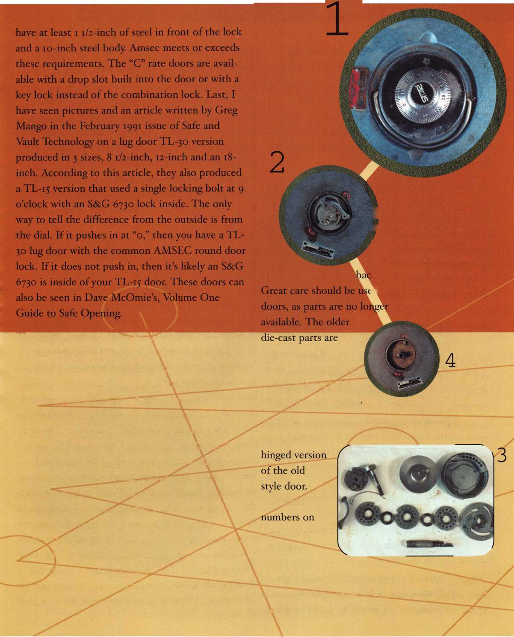

dial set to the side ot| the door. This dial is unique to Amsec; if it pushes in, you have t

Second, the drop-in is at 25, because the door  
needed a horizontal hinge side bolt so they could  
add a bolt detent to prevent the bolts from being

extended until the

changes or rotate

dial ring changin

the lift out door,

the wheels and tran:

This also

Ideation of the  
ito|i9 or 31. Like

olt cam; align

5-

The current and most common Amsec round door is seen in photos 8 through 15. This door can use either Sargent & Greenleaf or LaGard wheel packs. It has been manufactured in this current form since around i960. Serial numbers for this door will be greater then 22089.

Photo 7 shows the removable

uni' ^

currilnAoiodel do6r. The dialing sequence is 4

times lett, 3 times right, 2 times left, then right to  
“o,” push down and continue right stopping at 74  
to retract the bolts. This push-in feature allows  
Amsec to claim this as a manipulation-resistant  
lock. Resistant yes, manipulation proof - no.

Mark Swetland wrote an article in the  
September 1993 issue of Reed Security Reporter  
explaining how to manipulate it. The difference  
between standard manipulation and manipulating  
this door is how the contact area is read. Reading  
the contacts on this door involves measuring the  
travel of the dial as it moves up with a dial indi-  
cator. See Swetland’s article for a complete  
description. If manipulation either doesn’t work

or is not your forte, then lets look at how to drill this door. The factory recommended method is to set the dial at “o” and mark the door at 41. Measure out 7/8-inch from the dial center and drill a 1/4-inch hole about 7/8-inch deep through the steel door using a high-speed steel bit. Switch to a carbide bit to drill through the 1/8-inch of hardplate. Switch back to high-speed steel bit and carefully drill through the die cast cam. This will bring you out at the fence. Caution must be used when drilling at this location as it does any­time you drill at drop-in. There is very little room between the fence/bottom wheel and the cam or lock case. Drilling too deep will I damage/TwKfe^ror the fence — turning an easy open into a mess. Using a standard drill bit with a pointed tip can easily result in damage. Instead, after starting your hole through the drive cam or into a lock case, switch to an end mill or one of Northwest Safe and Vault’s special flat-sharpened drill bits. Switching to a different bit will help avoid this damage.

Once you have the hole into the lock area, use a dial like the one seen in photo 16 with the

number or “flat” section cutaway. Align the wheels, turn the dial back to “o,” push down,

Keynotes • September 2002

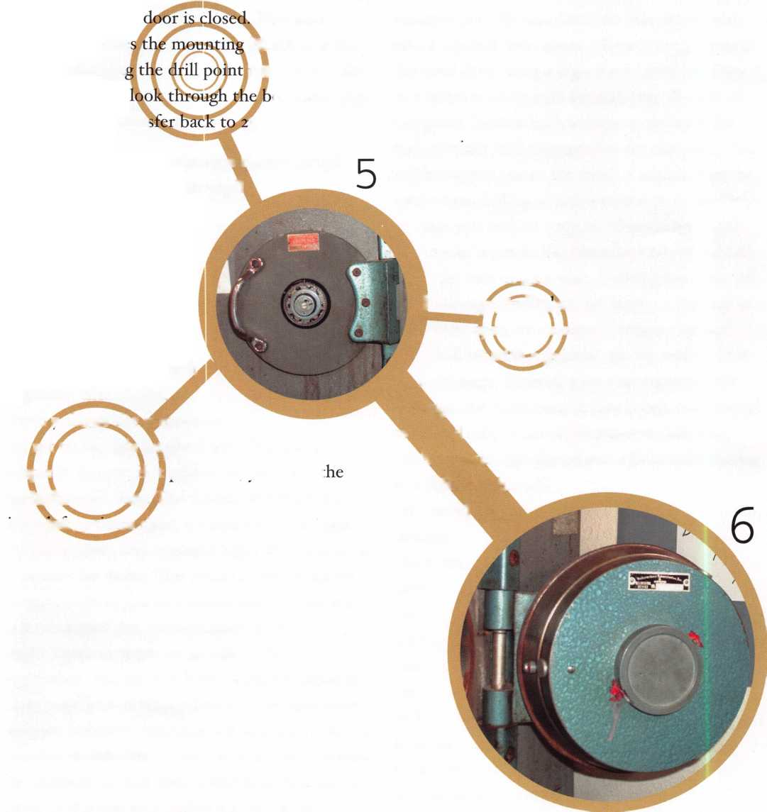

turn right and open the safe. A different alterna­tive is to drill under the dial ring at a slight angle about io degrees i 1/2 inches at 16. Our target area is shown in photos 13 and 14. Photo 15 shows the dial ring removed. The dial ring inner diame­ter is 2 1/2 inches and the outer diameter is 4 inches. The cam and hardplate inside is 3 inches, allowing a 1/4-inch overlap. This will bring you into the lock area through the

hole requires the use of a borescope and knowl-  
edge of transferring, most burglars (should they  
try to follow your hole) would get nowhere.

The hinged version of this door is seen in photos  
17 and 18; these photos are courtesy of Craig  
Smothers. As in the older version, hinging the  
door requires a bolt detent, which in turn

changes or rotates the dial ring  
mounting location. The drill

point is changed to 7/8-  
inch at 25 or 1 1/2 inches

at o; then you slightly  
angle inward to create

a scope hole.

away  
from any  
vital parts.

Insert a scope,  
align the wheel  
pack, and transfer  
25 numbers to  
open the safe. ’Vou

may need to adjust your  
numbers as you would any-  
time you transfer by adding or subtracting equally  
from all the numbers. The advantages to this  
location are threefold: First, your hole (and there-  
fore repairs) are concealed by the dial ring; sec-  
ond, there is little chance for damage to the door  
or lock (meaning you can repair and put the unit  
back in service without parts); third, since this

Although I have not worked on and don’t have any photos of the lug door TL-30, I wanted to

include the drill point informa­tion. According to Dave McOmie’s book (mentioned earlier), the drill point is 7/8-inch at 4. Relock pins are located 1 13/16-inches at 29, 62, and 96. I’m certain you could also drill 1 1/2-inches at 79 for a scope and

8

transfer location. This is probably the  
preferred location, since the dial is no  
longer available and the other location  
would require dial removal.

Service of the locks on these doors is similar to most safe locks. Prior to disassembly place an index mark on the back cover and the door, also an index mark on the cam plate after the back cover is removed. Start disassembly by removing the 3 screws holding the back cover in place. Next, remove the spline key and unscrew the drive cam from the spindle. Remove the spirolox retainer and remove all the wheels, flies and spac-

cam,

Keynotes • September 2002

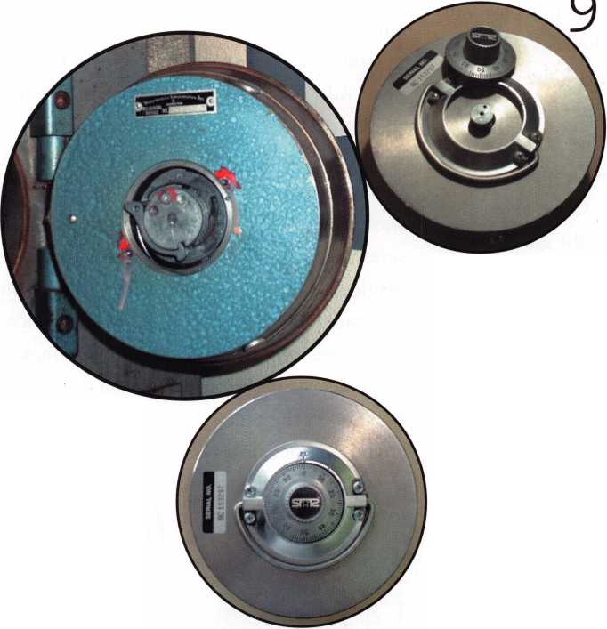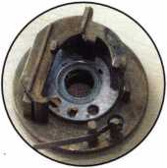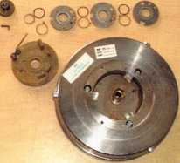

*1 C\ ers. Next, remove the

thin brass washer  
concealing the  
retaining ring  
and with a pair  
of external  
retaining ring pli-  
ers remove the

ring. This will allow

you to remove the cam

plate and the three bolts. Once the bolts are out,  
the relock pins and springs can be removed.

Clean all the parts in your favorite solvent (mine  
is L&R Nofome instrument cleaner followed by  
L&R rinse available from MSC industrial supply).  
This solvent is safe for use on most plastics  
including S&G “Celcon” wheels. Once cleaned,  
S&G and Amsec recommend a light grease like  
GE 322L on the wheel post inside and out, the  
three bolts, the underside of the cam in the bolt  
tracks, and on the spindle. If you’re using  
LaGard’s wheel pack, they do not recommend  
any lubricant on the wheel post. Re-assembly  
starts with the three relock springs and pins in  
their holes before installing the bolts and cam.  
Next, install the retaining ring making sure it is  
seated in its groove. Install the washer on the  
wheel post and then the number one wheel; this  
wheel will not have a drive pin on

the bottom side.

Select one  
of the two  
similar flies  
with the

smaller pin

and place it on the wheel. Add the spacing wash-  
er and the number two wheel. The number two  
and three wheels look alike with drive pins on the  
bottom, choose one and place it on the wheel  
post. Add a spacing washer, the third wheel and  
the last fly. Remember the number three fly has a  
larger drive pin to contact the drive cam. A final  
spacing washer is added and then the spirolox  
washer. Place the drive cam in the wheel post and  
screw the spindle into it until it is flush with the  
inside surface. Align the grooves of the spindle  
and cam and install a new spline key Place the  
fence assembly over the wheel pack, making sure  
the fence spring is properly placed by applying  
tension on the fence toward the wheel pack.

If you do not know the  
combination, dial the A" l|i^  
lock to /ii f* Jill \

15 -I ,

l **mf '** 1 all8n

y the  
wheels  
at the

change index prior to  
installing the back cover.

Or use a paper clip or probe  
to align the wheels at the proper location.

Using the change key to align the wheels is  
not recommended, since you can easily open  
a hub.

Keynotes • September 2002

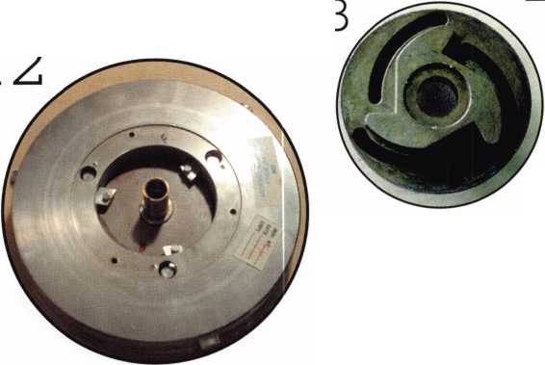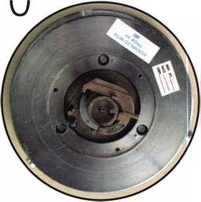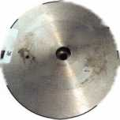

This will place the parts out of the correct timing sequence and potentially cause a lockout. Place the back on the door aligned with your index marks and tighten the three screws down. Insert

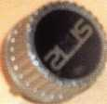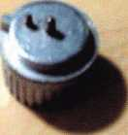

16

a change key  
into the

VX . .

lock, turn a

quarter turn and reset the combination. The  
change key for Amsec doors has a longer flag sec-  
tion between the wheel pack and the back cover  
than a standard key. It comes with the rebuild kit  
or you can order one separately. Test it several  
times including both half number high and low. If

the combination does not operate on  
both sides, reset it to the same numbers  
and try again on both sides. You may  
need to set the numbers slightly high or  
low of the actual combination to proper-  
ly center the combination.

Service kits are available from distribu-  
tors for the newer doors. M012700 is the  
part number for the kit with S&G wheels.  
M044000 is the kit with

LaGard wheels. Both kits  
contain all the parts for a  
door excluding the steel door  
itself. Since the base door is  
the same, a LaGard kit can be  
used to replace all the parts in  
an S&G door and vice-versa.

Individual parts are also available,  
to determine the correct parts please request a  
parts catalog from Amsec.

Amsec makes a quality product in this door as  
evidenced by the 40 plus years they have pro-

duced the same basic model. Few changes have  
been made to the design. Most notably, was the  
change from the thin steel spline key used in  
doors prior to serial number 449000 to the more  
common L shaped brass spline key used by  
LaGard, S&G and ILCO. If you need to service a  
door with the old style spline key and do not  
have any of the steel spline keys, I would recom-  
mend upgrading to the newer spindle, drive cam,  
and spline key

The main problem with these doors is abuse of  
the lift-out doors. Most users think the door can  
be slammed or thrown on the ground. It’s a little  
heavy, so after they lift it out of the body, it gets  
slammed onto the floor next to the safe. This can  
damage the back or cause the screws to back out,  
tripping a relock (or all three).

They are located on the  
lift out door 1 13/16-

inches at 1.5, 34.5  
and 67.5. If  
working on a  
hinged door  
remember to  
rotate the loca-  
tions to 88.5,

21.5 and 54.5. The  
relock pin at 21.5

does not need to be

drilled, since drilling for the  
other two will allow the door to swing.

Once you understand these doors, they can  
be a very profitable door to work on — or to

open. The hardplate is not difficult to drill, and  
for the newer style doors, parts are readily avail-  
able. Next month, we’re going to look at some  
neat tools, opening aides and alignment tools  
introduced at the ALOA 2002 Convention. Q

Keynotes • September 2002

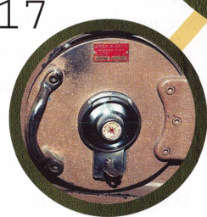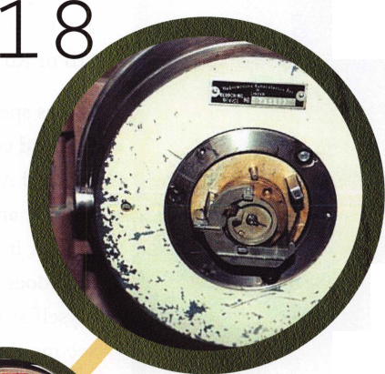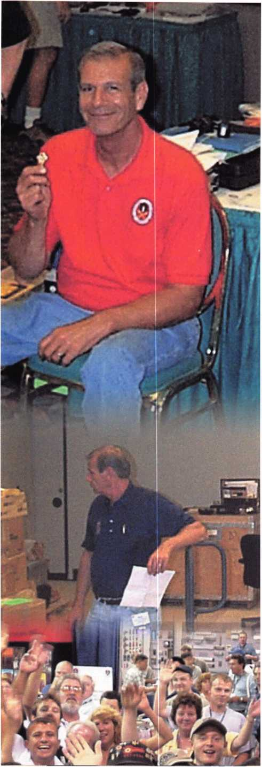

“Speechless” Stafford Hauls in the ALOA Lifetime of Outstanding Achievement Award

by Jim DeSimone

Bob Stafford, a Certified Master Locksmith who has been the head locksmith at the University of Hartford for over 20 years, has received the security industry’s highest honor - the Associated Locksmiths of America’s (ALOA) Lifetime of Outstanding Achievement Award. The award is granted annually at ALOA’s yearly Security Expo and Conference, held this year in the Chicago sub­urb of Rosemont, IL, from July 22-28.

“I was speechless, and that’s rare for me,” said Stafford concerning his reaction to winning the coveted ALOA Award. “I do what I do because I enjoy it and get a lot out of it. Don’t get me wrong;

I think it’s an honor to be recognized as a person who does something above and beyond. I don’t see myself as that sort of person, but I’m glad my peers see me that way Honestly, I don’t feel I should be recognized, but I really consider it probably the top award. Now I really want to continue to help out wherever I can.”

The moment was almost surreal for Stafford, a man as easygoing as they come.

“Whenever I see someone I know get an award,

I get a tear in my eye; and usually, after all these years, you go to a meeting like this and you’re almost half-listening,” he said. “On one hand, you



Keynotes • September 2002

Yale® and Yale Security Inc.® are registered trademarks of Yale Security Inc. SecureX™ is a trademark of Yale Security Inc.

Sure, old Spike here will do the job. But you're going to have to feed him and walk him. SecureX,™ our new patent pending controlled exit device with delayed egress, will stop anyone in their tracks without taking a bite out of their backside. It's the kind of product you've come to expect from Yale, one of the most respected names in the industry. So you have a decision to make. Contact us at 888-828-8349, or visit our website at [www.yalelocks.com](http://www.yalelocks.com) to find out more. Or go buy 50 lbs. of dry dog food.

Delayed Egress Exit Device

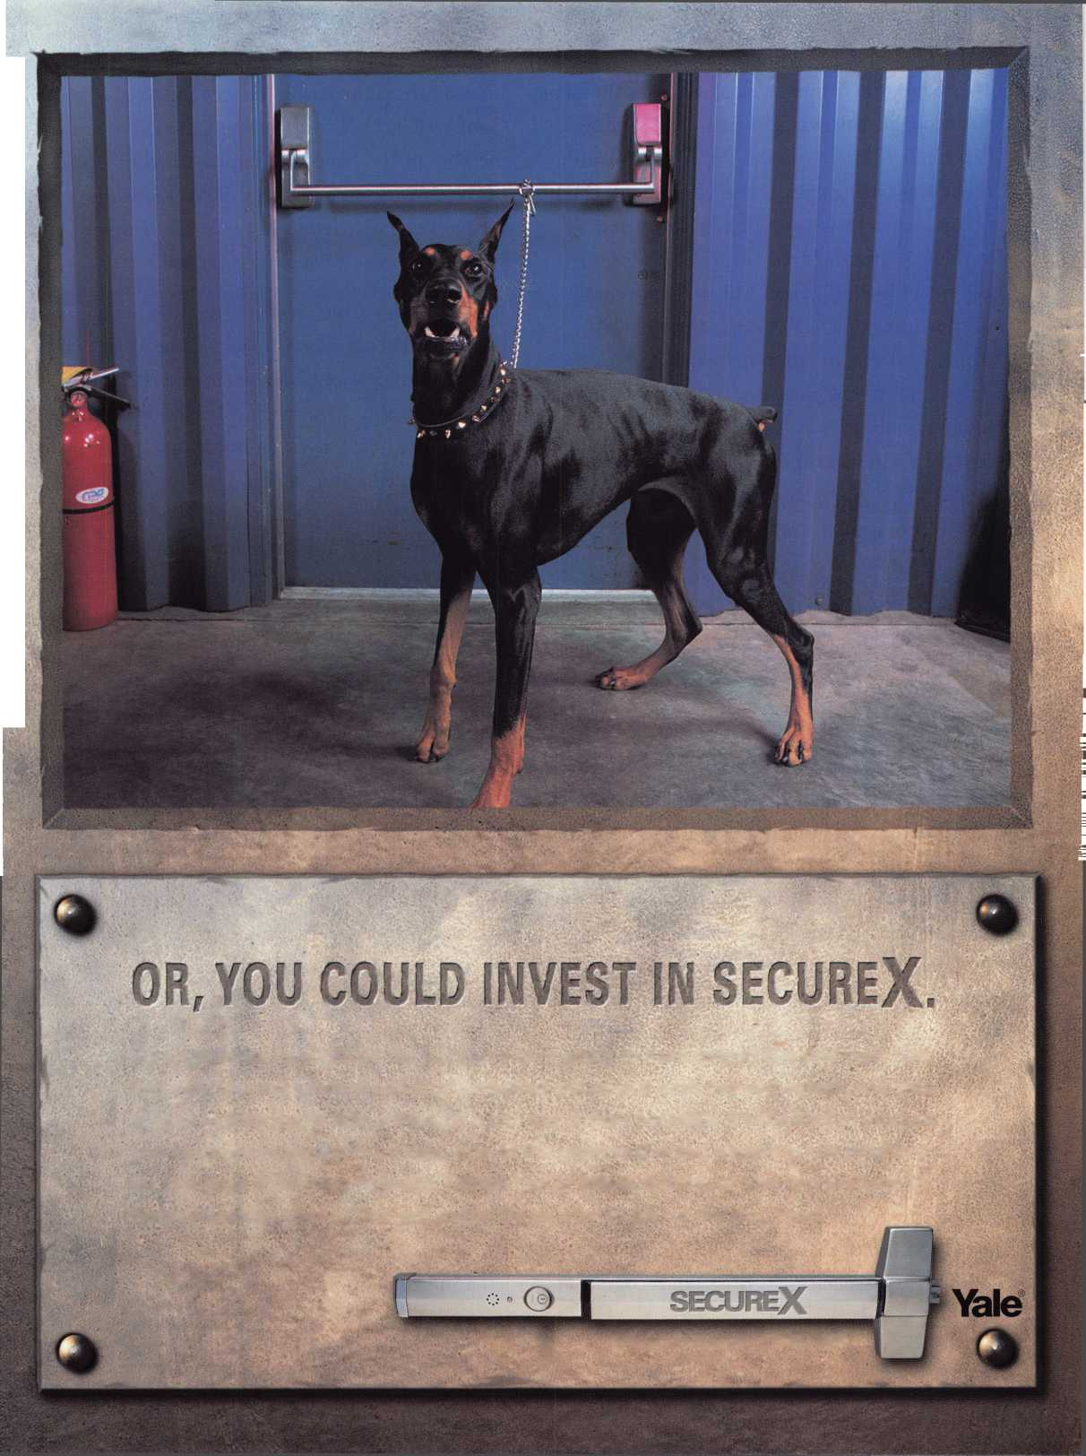

i

want to find out who won the awards, but on the other hand, the format is almost always the same, so it’s tough—this was sort of surreal. Lenny [Passarello, CML], won the President’s Award, and he was sitting with David [Paulsruud, CML] and me. Since David and I had also won the President’s Award, I told Lenny, “This is great; now you’re like us!” Then I heard {last year’s award winner and ALOA Award presenter] Jerome Andrews mention my wife’s name, Christa, out of the corner of my ear, so to speak. And in my head I was thinking, ‘Not many peo­ple have a wife named Christa’ and everybody was already clapping and waiting for me to go up and give my speech. I was just shocked by the whole thing.”

It was the icing on the cake for Stafford, whose career accomplishments read like a laundry list of all the available achievements a locksmith can attain.

His first job was in the Shipping and Receiving department at Stony Brook University in New York. There was soon a opening for an appren­tice locksmith. He applied and got the job. He has worked as an institutional locksmith ever since. He took all the local locksmithing classes that he could find and, after joining ALOA, took many of the ALOA Continuing Education (ACE) classes offered. He is currently the locksmith for the University of Hartford.

He served on the ALOA board from 1991-98.

He received the President’s Award from ALOA. He was the President of the Connecticut Locksmiths Association 1990-1991. He received an award from the Greater Philadelphia Locksmiths Association (GPLA) in recognition

of his time as president of the Connecticut j

Locksmiths Association. He is a member of the !

<

Connecticut Locksmiths Association, a founding 1 member of the Nutmeg Chapter of ALOA, and J of the Institutional Locksmiths Association. '

He has been married to his wife, Christa, for j

33 years, and has a daughter, Christal.

And all of this from relatively humble beginnings. j Bob’s first encounter with locks came at an early j

age. His father was a Navy man, and the family |

was stationed in Brunswick, Maine, for several 1

years. Rather than live in a house on base, Bob’s j father decided to buy an old farmhouse situated i in the middle of several acres of wooded land. **j**

There was plenty of fishing and swimming and j

hide-and-go-seek for young Bob, but it was his '

encounter in an old barn that kicked off his

**interest** in locks. j

I

“Behind the farmhouse, there were two concrete j storage barns built underground,” he said. “It was j

dark and cool in them, and I believe they were J

<

originally used to store potatoes. By the time we ! moved there, there were countless old tools and j screws and things you’d leave in a garage, all j

kinds of stuff. But out of it all, the one thing \

that caught my eye was an old padlock I found j

there. It had a brass insert that was encased in 1

steel, and I really, really liked it. Years later, when I became a locksmith, I made a key for it and got it working again. I still have it as a keep­sake today”

The ALOA Award is presented annually to a member of the security industry for overall excel­lence in the profession, and for being a profes­sional who typifies the award’s slogan of having led a “lifetime of outstanding achievement.” Q



Keynotes • September 2002

“Quick-Out” Emergency Trunk Release

Prevent Tragedy - Install a “Quick-Out” Device Today

Fits Virtually All Model Autos

Easy to Install

QUICK-OUT INSTALLED

A Child Can Easily Release the Trunk Latch from  
Inside of the Trunk to Escape

Federal Law in new vehicles. A must for all others.  
In packs of 10 FREE Window Poster

$11.00 ea + $3 S&H

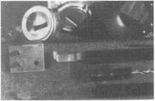

The Innovator

1998 and up GM in-dash ignition removal kit.

Patent 5,454,245

Removes plastic ring and chrome cap in seconds; makes access hole to pick side bar; turns cylinder to ACC position. Removes lock in less than five minutes with no damage to lock. Your first job will more than pay for the kit.

Introductory price: $70.00 + $4 S&H



1996 and up 8-Waffer Ford Ignition  
Removal Kit and Side Bar Breaker Tool

Patent 5,701,773

Turn ignition to “ON” position in less than 60 seconds for fast removal or use kit to

push side bar in, then turn cylinder to “ON” position without any damage. Fit key, replace same lock. Or use the force tool to  
turn to “ON” position for fast removal in 60 seconds; no damage to waffers. $90.00 + $4 S&H

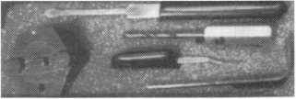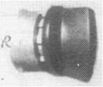

FINISHED CYLINDER

1994 and up 9-Waffer GM Ignition Removal

Patent 5,454,245

A new system for the future. These locks have side bars longer than the old type and must be in  
the “ON” position to remove the cylinder. My tool will do this. Best of all, you will not damage

the cylinder. You can repair, fit key and replace the same cylinder. Do only one job and you will have the price of the kit paid for. A  
replacement cylinder costs about $22.00, VATS $45 our cost. Order one today at my special introductory price, and be prepared for  
these new locks. $60.00 + $4 S&H. ***Upgrade it for ’95 Blazers, Suburbans, S-10 Pickups, etc. $20.00 + $4 S&H***

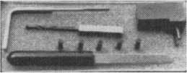

Tool Kit

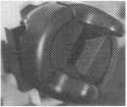

FINISHED CYLINDER

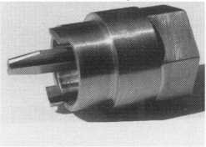

Ford “Quick On”

Patent 5,454,245

Now turn all 10 cut ignition cylinders to the “ON” position for fast removal - in less than 60 seconds. Sable, Taurus, all styles, even with airbags. No damage to housing.

**$65.00** + $4 S&H

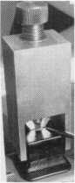

No-Nonsense Squeeze Lock Plug Remover

Patent 5,165,158

Now you can remove all squeeze lock plugs in 15 seconds or less, from all GM, Ford, Chrysler, AMC, Jeep, no more fumbling, gadgets, cut fingers, broken tabs, need for 3 hands for removal of lock. It’s so easy you can do it in the dark, while it’s still in the glove box. $50.00 + 4 S&H

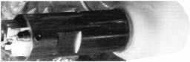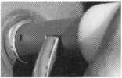

The GM Persuader

This unique tool will open virtually all GM trunks and doors, through the current year, where tool fits into the cylinder core cavity,  
in less than 50 seconds. No drilling, pulling, picking, special tools, or electric needed. When customer’s key does not open trunk

because: Problem 1: spring retainer popped up into outer shell; Problem 2: one side of side bar sprung off side bar  
does not retract; Problem 3: key or cylinder worn side bar does not retract; Problem 4: key jammed in lock in  
“turned” position, etc. With The Persuader you will open these locks in less than 50 seconds. No damage to lock, just  
repair and replace, nothing to wear out. Yes, if needed, it will open with no key.

Note: because of The Persuader’s capabilities, it will be sold to locksmiths only. $45.00 + $4 S&H

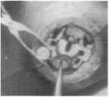

Ford Disc-Out Kit

Patent #4,682,398

A tool kit to remove those stubborn Ford pin ignition locks from 1976 through the current year. These locks incorporate 2 locking devices and a hard steel disc across the shear line. They must be in the “ON” position, to release both locking devices, so as not to damage the housing. I guarantee the job to take 5 minutes with my kit. Complete Kit$60.00 + $4 S&H

Aable Locksmiths • 86-19 97th Avenue • Ozone Park, NY 11417 • 718.849.8000 • 718.835.5117  
Frank Markisello guarantees all of his products to do as stated or your money back!

Website: AABLELOCKSMITHS.COM

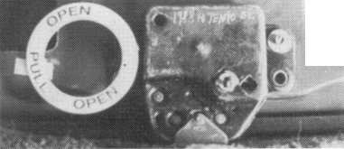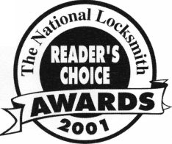

Medeco’s

HEW VERSION

of Key Wizard Key Management Software

By: Gordon Malczewski

jr addition to tracking keys, keyholders, locations, hardware and cylinderinventory, the latest version of Key Wizard™ allows users to import k keyholders and location j ^\. information.

Medeco first introduced its Key WizardIM Key Management software in July  
of 2001. After being on the market for almost a year, Medeco has announced  
the release of a brand new enhanced Key Wizard1 Mversion, 3.0. Medeco has  
included several enhancements in the new version, which are designed to  
make the software more versatile and easier to use.

In addition to tracking keys, keyholders, locations, hardware and cylinder  
inventory, the latest version of Key Wizard1X1 allows users to import keyhold-  
ers and location information. The user simply places the information into an  
Excel( spreadsheet format according to a sample file and specifications con-  
tained on the software CD. The information can then be imported into  
Key Wizard™. This feature saves time by reducing the need to manually  
input employee and location information. Version 3.0 gives users the option  
of turning off the requirement to input key bittings. This option is useful  
for users who only want to track the keys that employees carry, or who may  
wish to track special or unusual keys for items such as locksets, padlocks,  
safes, etc.



Locksmith dealers can now pre-load master key system and location infor­mation into their copy of the software and then export the information. End users can then import the information into their copy of the software. Providing this value added service can help locksmiths sell more master key systems. This feature provides a “one time” download and is not designed to synchronize information back and forth between the locksmith and the end user.

Keynotes • September 2002

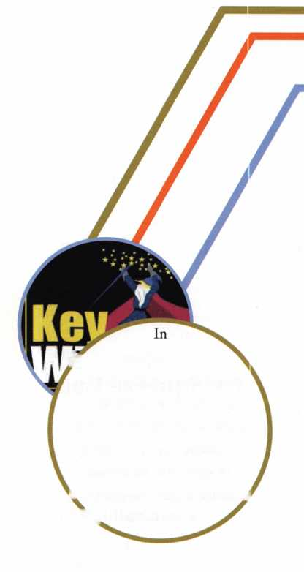

One of the unique features of Key WizardIM is the  
true logical sorting of Standard Key Coding labels.  
Many other types of key management software  
sort special function keys, such as “MAINT,” with  
the master key “MA” and usually sort the change  
keys as: AAi, AAio, AAn, AA2, AA3, AA4, etc.

In contrast, Key WizardrM places special function

Key Wizard™ aims to establish uncluttered, easy-to-navigate screens using a Microsoft™ Outlook™ type of layout. (See figure 1) The pro­gram is able to track multiple end users and multi­ple master key systems. It is suitable for both retail locksmiths with multiple customers, and for institutional users, such as hospitals and universi­ties, that may need to track multiple master key systems. It is available in network and single user versions. Key Wizard™ works with most major lock manufacturer’s master key systems. The soft­ware accepts Medeco™ Original angles,

Biaxial™single and double-cut angles and bittings for up to 7 pin positions.

A keyholder import screen (See figure 2) allows users to import scanned pictures of keyholders, along with a sample of their signatures, to insure that keys are issued to the proper individuals.

The system tracks key deposits and has a sample default key receipt that can be printed using either a standard laser or inkjet printer or a small­er format point of purchase printer, such as those used to print credit card receipts. (See figure 3)

An expandable access tree screen allows users to easily see, on one screen, all the keys a person carries and all of the doors those keys will access. This feature makes it easy for supervisors to see which rooms their employees can access. (See fig­ure 4)

Extensive location door hardware screens allow users to track detailed information on such items as primary and secondary locks and cylinders, doors, frames, hinges, door closers, push plates, pull plates, mop plates, kick plates, door viewers and thresholds. (See figure 5)

Keynotes • September 2002

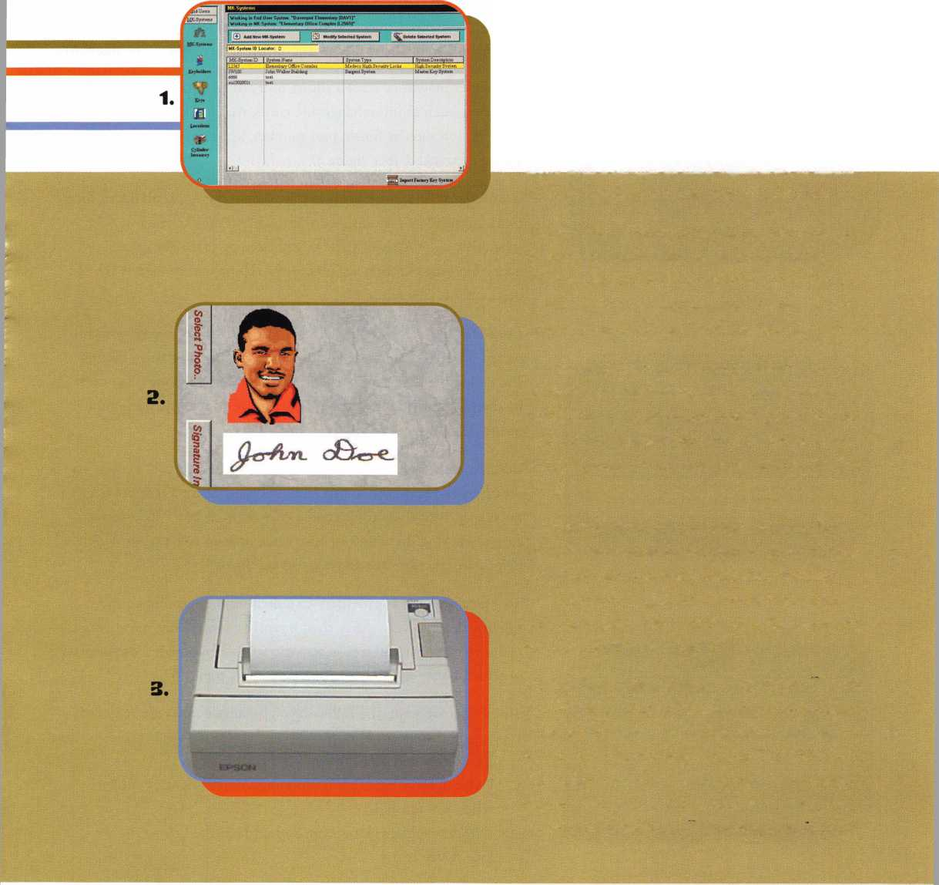

feyholder

**Full Keyholder Access Below**

-j—__sr Name  
Ag us tut Acosta

**&A (2R23B)**

**h<BUILDING>: Administration <DOOR#>: 101 <ROOM#>: <DEPT>: Gift Shop**

**<BUILDING>: Convent <DOOR#>:102 <ROOM#>: <DEPT>: Administration**

**<BDILDING>: Administration <DOOR#>: 104 <ROOM#>: <DEPT>: Gift Shop**

**AA (2R23B)**

**EbAAl (2R23B)**

**<BUILDING>: Administration <DOOR#>: 101 <ROOM** H>: **<DEPT>: Gift Shop**

**B-AAl (2R23B)**

**“<BU1LDING>: Administration <DOOR#>: 101 <ROOM#>:**

**B-AAl (2R23B)**

**<BUILDING>: Administration <DOOR#>: 101 <ROOM#>: <DEPT>: Gift Shop**

- **AA1 (2R23B)**

**<BUILDING>: Administration <DOOR#>:101 <ROOM#>:**

**AA2 (2R23B)**

**; <BUILDING>:,**

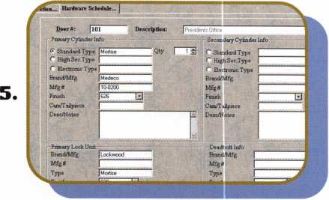

b.

Service Start Date: Total# of Occurrences:

U Single Service C Weekly (* Monthly ^

Service Description

Check door closer adjustment This door is opened about 300 times a day. If found leaking, replace with

1.

Working in End User System “Davenpot Elementary (DAV1)“

i Office l

| Cylinder Type

**MC212**

MC213

MC214

] In-Stock

keys, such as “MAINT”, at the beginning of the key list and sorts  
change keys as: AAi, AA2, AA3, AA4, AA5, AA6, AA7, AA8, AA9,  
AA10, AA11, etc. This feature makes it easy to keep track of keys  
and read audit reports. Users have the option of choosing “Standard  
Key Coding,” “Modified Key Coding” or their own system of label-  
ing keys.

Another feature of Key Wizard™ is the Maintenance Service  
Scheduler. Users are able to schedule routine maintenance tasks,  
such as cylinder lubrication, on a one-time, weekly, monthly, quar-  
terly, or yearly basis. A pop-up screen will automatically alert the  
user when maintenance is required. A special report can be printed  
for both scheduled and completed maintenance tasks. (See figure 6)

A cylinder inventory screen allows users to keep track of pinned  
cylinders, such as interchangeable cores, that are kept in stock.  
Information such as finish, part number, key symbol and location  
are easily tracked. (See figure 7)

A variety of different reports are available on keys, keyholders, loca-  
tions, master key systems, overdue keys and maintenance service  
schedules, all of which can be customized by using the extensive  
query function. Version 3.0 provides a report on keyholders by  
department. (See figure 8)

Data files are encrypted and access to the software is password pro-  
tected. Privileges such as viewing records, editing records, issuing  
and collecting keys can be enabled or disabled, for individual users,  
by the program administrator. This feature provides security and  
insures data integrity. (See figure 9)

Both an on-screen and printed “Quick Start” guide enable users to  
set-up and operate the software quickly and easily. Version 3.0  
includes printable help files and a copy of AcrobatIM Reader for  
ease of viewing. In addition, on-screen, pop-up tool tips provide  
helpful instructions for all major screen fields.

Technical support is provided via a dedicated 800 number and is  
free for the first year. After that, a yearly maintenance fee covers  
technical support and free automatic software upgrades. Support is  
provided between the hours of 8 a.m. and 5 p.m. EST.

To use the program, the following eight simple steps are required:

1. Set up system preferences
2. Enter new end user information
3. Enter descriptive field for buildings, departments, cylinder  
   types and finishes
4. Add new master key system and set levels of keying  
   (See figure 10)

Keynotes • September 2002

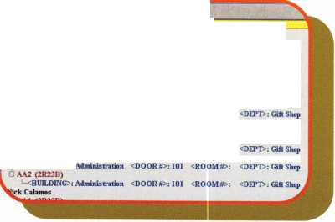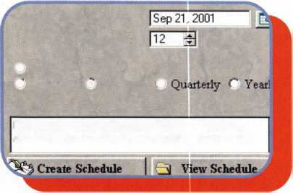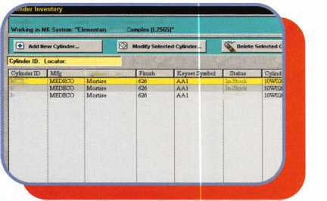

8.

**Select Report to Print...**

|  |  |
| --- | --- |
| ^ Single Keyholder Access Report... | | ^ All Current Keyholders Access Report |
| Keyholders by Name Report | Keyholders by Department Report |

Keyholder / Issued Keys by Department Report

Cancel

1. Add keyholders and assign authorized individuals (See figure 11)
2. Add keys, key symbols, blind codes, bittings, keyway and gener­ate key quantities (See figure 12)
3. Add locations, keys to locations, maintenance schedule and hardware (See figure 13)
4. Issue keys and print authorization forms

Key Wizard™ software requires a minimum of a 350 MHz processor or faster, 60 MB hard disk space, Windows 98, 2000, ME, NT or XP, 16 MB RAM, CD drive and a mouse pointing device. For better performance, a 500 MHz processor or faster, 70MB hard disk space and 64 MB RAM is recommended. Network and single user ver­sions are available along with a demonstration disk. Since the soft­ware is able to track multiple end users and multiple master key sys­tems, the locksmith dealer version and the end user version are one in the same. The demo disk is a working version of the software, so users are able to test the full functionality of the program. The demo disk limits keyholders, keys, locations and cylinders to 20 records. When the user is ready to purchase a full working version of the software, a new disk is sent. Data cannot be transferred from the demo disk to the full version of the software.

To purchase Key Wizard™ software or to request a demo disk, contact Medeco customer service at 800-839-3157 (USA), or 888-633-3264 (Canada).

For technical questions or detailed product information contact Key Wizard at 800-610-1706. Q

|  |  |  |  |  |  |
| --- | --- | --- | --- | --- | --- |
| First Name: (Gordon | |  | Last Name : | jMalczewski |  |
| User ID: | j admin |  | Password: | | admin |  |
| User Level: | (User | d |  |  |  |

d User Systems

' No-View r View AH f* Edit

—7 Register r No-View r View All Edit

MK System

j r No-View C View AH f? Edit

—View Key Bitting in Key Register

C No-View r View AH

Issue Keys

No-View O Viewlssuedf* Edit

Adjust Key Hook

Generate Keys and Serial numbers

w

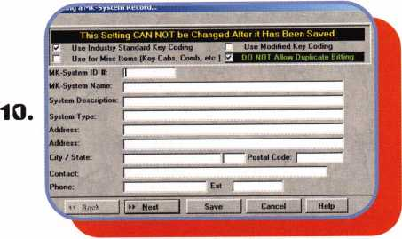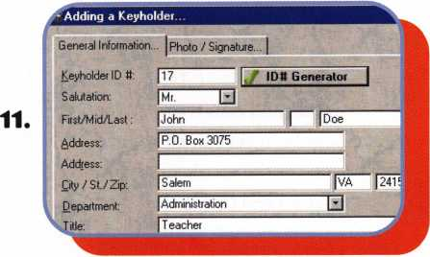

12.

Kejway:

Blind Code:

Key Cabinet#: Hook U:

Key Description: Date:

jjun H 2002'

13.

|  |  |
| --- | --- |
| jAdmmstt abort | □ |
| |lntenor |  |
| (Guidance Office | |

Keynotes • September 2002

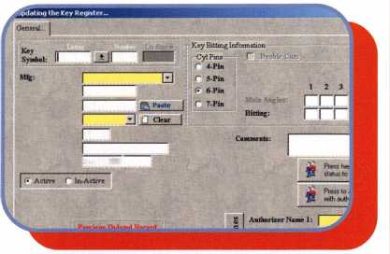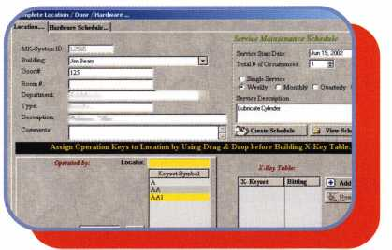

Transponder Secrets: Toyota and Lexus

Last month, we covered the servicing of the Lexus RX300 SUV. This month, well broaden things a bit and cover some of the tricks you can use when servicing all Toyota and Lexus transponder-equipped cars.

Since the introduction of transponder systems to the North American Locksmith market, it has been chal­lenging to say the least. Until recently, the Toyota and Lexus transponder sys­tems have been very costly to the owner (to say the very least). Last July,

I was approached by Mr. Tom Seroogy from Lockmasters to work on a project with Mr. Randy Mize in cracking the Electronic Control Module (ECM) problem, which stood in the way of making keys for the Toyota and Lexus. Needless to say, I did a little snooping on the net and found out what manu­facturer was in partnership with Denso on the transponder system, along with some other information that I gath­ered. In no time, I knew which IC chip was responsible for the transpon­der system. Being in the electronics business, I have found that program­ming EPROM’s for AC and/or alarm systems and doing automotive ECM’s are no different — except ECMs are now a lot smaller with the SOT tech­nology. Another point is that you can program most of the ECMs right on the board, providing you have a good connection and can verify your work prior to programming the IC chip. It’s also good practice to verify your work after you send the right checksum (binary code representing data) value to the chip. There are units out there that have some success on program

ming the ECMs, but the reality is that there are a lot of values that come into play when programming these ECMs. For instance, are you using the right checksum with the right ECM? Can you verify your checksum that you pro­gram into the ECM? Not all off the ECMs can be programmed on the board; some have to be removed, then programmed, then re-installed on the board. I have sent one of my staff members to a company for a week in becoming ISO 9001 certified for work­ing on SOT Technology. **You** need to have a clean room when working on the electronic boards, because Electro- Static Discharge (ESD) can and does bite you if you do not take the proper measures. Listed below is a compila­tion of ECMs with part numbers of the ECMs that we have successfully programmed.

Another note is that when you have an ECM reprogrammed, the first two keys presented to the ECM are now what is called the “master keys,” which allow you to do onboard programming on the vehicle. In my opinion, this is a bad play on words, because if you pres­ent a valet transponder as one of the first two keys, it now becomes a master key that can be used also to program additional keys using the onboard method. It would be better to state that the first two keys presented to a re-programmed or new ECM should be called the Programming Onboard Keys. So when programming your first two keys to the ECMs, make note of them and have them identified in such a way that you know which key to use to do the onboard programming.

By Bill Neff, CML

When you put new keys into the ECMs, it will accept three keys with­out having to do the onboard program­ming. You must have at least three keys programmed into the vehicle before the security light stops flashing. What we have done recently is pro­gram two factory original Lexus keys first, and they are easily identified as the program keys and the Ilco-Kaba key becomes a non-on-board program key. Another point when doing Lexus for certification, you need to have at least one remote key to certify the vehicle. You can order a factory cut key right from the Lexus dealer and then first program the key to start the vehicle, and then do the remote pro­gramming. I find that following this procedure works best.

Lexus/Toyota Remote Key Programming 1998 and Up

1. Enter the car make sure all doors are lock with the manual locks.
2. Manually unlock the driver's side door.
3. Open driver's side door.
4. Insert remote key into ignition but do not turn on.
5. Remove remote key from ignition.
6. Lock/Unlock the manual lock button or the electric lock buttons five times on door panel in a rhythmic one second lock and unlock action.
7. Close driver's door
8. Open drivers door
9. Repeat step six
10. Insert remote key into ignition and turn on position but do not start!
11. Turn key off and remove key from ignition.

Note: At this time you should see the all the doors lock and unlock one time.

This tells you that the car is now ready to accept remote programming.



Keynotes • September 2002

1 2) Simultaneously, hold down the lock and unlock button on the remote for a period of about three seconds or until you hear two beeps.

13) Release both buttons of the remote.

Note at this point you can select either step 14 A or Step 14 B 14A)If you depress the unlock button on the

remote you should hear a click but note the doors are already in the unlock mode.

14B) If you depress the lock button on the

remote you should hear a beeping sound that goes for about 10 seconds and the doors will not lock. The reason for this is because you have the driver's side door open. Make sure all doors are close includ­ing the hatch or trunk then the doors will lock with the use of the remote.

1. At this point try all three remote buttons for operation.
2. To end the program close the door this will end the programming cycle.

If you want to program additional remotes you can repeat steps 13 through 14B. You must program all remotes into the system in about a 45 second span because the system does a time out.

Another note: I discovered this proce­dure does not erase previous remotes. You can repeat this procedure to add other remotes.

Also make sure you have the remote for that model and make. It is appar­ent that Lexus and Toyota have several different remotes and their must be different frequencies.

Another note the remote system is semi-independent of the immobilizer system.

Another note in the procedure men­tion above the key that you insert into the ignition must be a programmed key into a valid key that will start the ignition. It can be a master or valet it does not matter.

The maximum number of remotes allowed to be programmed is a quanti­ty of six. It does a FIFO function. FIFO means first in first out in other words it does not fill up the storage

buffer and unlike other systems it does not need a special programmer to reset the values it just does a roll over meaning the oldest remote pro­grammed into the system will be dropped when the seventh remote is added.

Now listed below are the part num­bers and the locations.

Toyota’s & Lexus ECM’s Locations:

4-Runners You will find it located under the glove box. Use a 10 mm socket to remove the glove box. The ECM is mounted sideways and the five connectors will be facing towards you. The ECM is right under the air duct.

• classes and

tet NOIN lot Education

For more information, visit us online [www.yankeesecurity.org](http://www.yankeesecurity.org)

Yankee Security Conference

*The best locksmithing event in New England!*

NOVEMBER 6-10, 2002

STURBRIDGE HOST HOTEL | STURBRIDGE, MA

Keynotes • September 2002

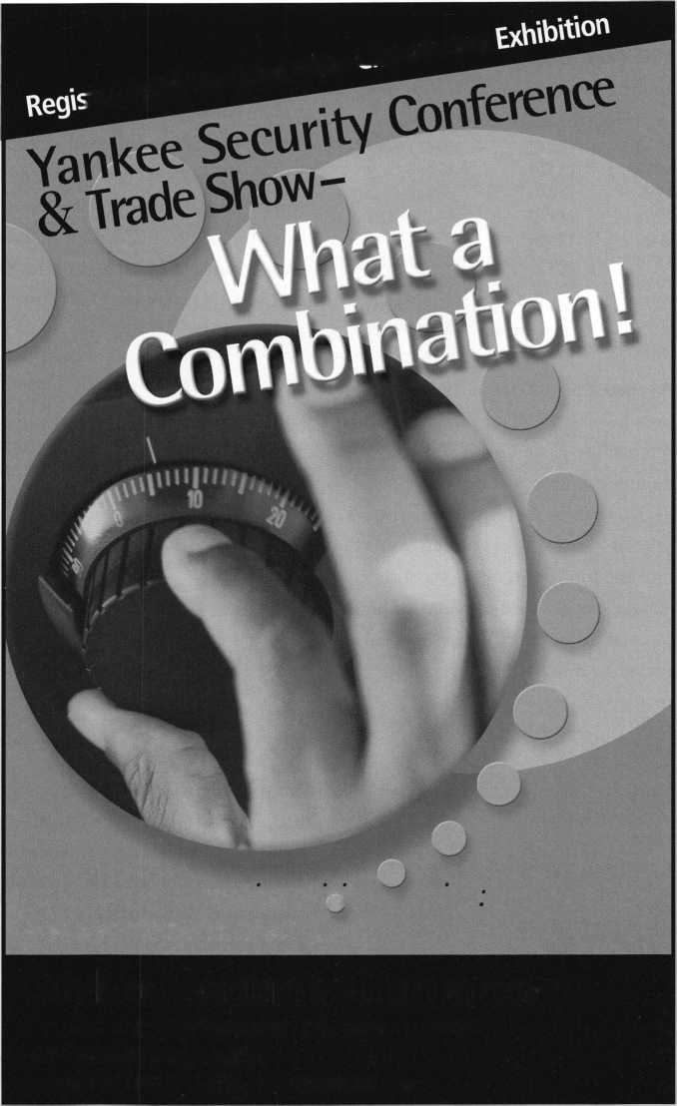

|  |  |  |
| --- | --- | --- |
| 1999 | 4-Runner | 89661-3D570 |
| 1999 | 4-Runner | 89666-35420 |
| 1999 | 4-Runner | 89661-3D550 |
| 1999 | 4-Runner | 89661-3D600 |
| 1999 | 4-Runner | 89666-60260 |
| 2000 | 4-Runner | 89666-35120 |
| 2000 | 4-Runner | 89666-35170 |
| 2000 | 4-Runner | 89666-35121 |
| 2000 | 4-Runner | 89666-35140 |
| 2000 | 4-Runner | 89666-35150 |
| 2000 | 4-Runner | 89666-35170 |
| 2001 | 4-Runner | 89666-35420 |
| 2001 | 4-Runner | 89666-35410 |

LX-470 & Land Cruisers **You** will find it located under the glove box. Use a 10 mm socket to remove the glove box. The ECM is mounted horizontal and the five connectors will be point­

ing towards the driver’s side.

|  |  |  |
| --- | --- | --- |
| 1998 | LX470 | 89661-60610 |
| 1999 | LX470 | 89666-60261 |
| 1999 | LX470 | 89666-60260 |
| 1999 | LX470 | 89666-60610 |
| 2000 | LX470 | 89666-60170 |
| 1998 | Land Cruiser | 89661-60610 |
| 1998 | Land Cruiser | 89661-60611 |
| 1999 | Land Cruiser | 89661-60610 |
| 1999 | Land Cruiser | 89666-60260 |
| 2000 | Land Cruiser | 89666-60170 |

Avalon You will find it located under the glove box. Use a 10 mm socket to remove the glove box. The ECM is mounted sideways and the five con­nectors will be facing towards you. Special note on 1999 Avalons you will find the top 10mm nut is way back almost straight up and seems to be secured by locktite. We use a deep socket 10 mm with a universal to

remove the top 10 mm nut.

|  |  |  |
| --- | --- | --- |
| 1998 | Avalon | 89661-07151 |
| 1998 | Avalon | 89661-08050 |
| 1999 | Avalon | 89661-07160 |
| 1999 | Avalon | 89661-07132 |
| 1999 | Avalon | 89661-07220 |
| 1999 | Avalon | 89661-07222 |
| 1999 | Avalon | 89661-07230 |
| 1999 | Avalon | 89661-07231 |
| 1999 | Avalon | 89661-07340 |
| 2001 | Avalon | 89661-07311 |
| 1998 | Avalon XL | 89661-07143 |
| 1998 | Avalon XLS | 89661-07133 |
| 1999 | Avalon XLS | 89661-07132 |
| 1999 | Avalon XLS | 89661-07240 |
| 2000 | Avalon XLS | 89661-07260 |

**36**

LS400 **You** will find it located under the glove box. This ECM removal takes the most time to remove about 20 minutes max. Use a 10 mm socket to remove the glove box. If it has a CD player remove it. You will see the ECM it has five mini-modules that are attached to the ECM with brackets you most removed them from the ECM before you can remove the ECM from under the dash.

1. LS400 89661-50433
2. LS400 89661-50501

Camry & Camry XLE You will find it located under the glove box. Use a 10 mm socket to remove the glove box. The ECM is mounted sideways and the five connectors will be facing towards you.. Remove wire connec­tors attached to ECM then remove two 10 mm nuts attached to the ECM brackets then remove ECM from

under the dash.

|  |  |  |
| --- | --- | --- |
| 1998 | Camry(4 Cyl) | 89661-06540 |
| 1998 | Camry | 89661-06591 |
| 1998 | Camry | 89661-3T311 |
| 1999 | Camry | 89661-06631 |
| 1999 | Camry | 89661-06711 |
| 1999 | Camry | 89661-07340 |
| 1999 | Camry | 89661-0W091 |
| 1999 | Camry | 89661-3T410 |
| 2000 | Camry | 89661-07260 |
| 2001 | Camry | 89661-06181 |
| 1998 | Camry XLE | 89661-06560 |
| 1998 | Camry XLE | 89661-06561 |
| 1998 | Camry XLE | 89661-06580 |
| 1998 | Camry XLE | 89661-08030 |
| 1999 | Camry XLE | 89661-06640 |
| 1999 | Camry XLE | 89661-06641 |
| 1999 | Camry XLE | 89661-06731 |
| 2000 | Camry XLE | 89661-0W111 |

ES300 You will find it located under the glove box. If it has a CD player remove it. First remove the faceplate around the CD player then remove two 12 mm nuts which are brass in color. Push back on CD player then drop down out of way. You will see the ECM remove two 10 mm nuts slide ECM out of car.

1998 ES300 89661-3T310

1998 ES300 89661-3T321

|  |  |  |
| --- | --- | --- |
| 1998 | ES300 | 89661-3T341 |
| 1998 | ES300 | 89661-3T343 |
| 1998 | ES300 | 89661-06613 |
| 1999 | ES300 | 89661-3T420 |
| 1999 | ES300 | 89661-3T422 |
| 1999 | ES300 | 89661-0W103 |
| 1999 | ES300 | 89661-3T423 |
| 2000 | ES300 | 89661-0W120 |
| 2000 | ES300 | 89661-0W121 |
| 2001 | ES300 | 89661-0W150 |
| 2001 | ES300 | 89661-0W151 |

LS430 The ECM is located under the hood in front on the driver’s side just about the headlight. You will see a large black plastic box a outer cover attached by three 10mm bolts then remove two 10 mm nuts from the cover lift the cover and you will see the ECM is attached by another two 10 mm nuts. Note: you have six con­nectors instead of five. Remove all wire connectors then slide ECM out of box.

2002 LS430 89661-50660

GS300 & GS400 The ECM is locat­ed under the hood in front on the dri­ver’s side just about the headlight.

You will see a large black plastic box. Remove two 10 mm nuts from the cover lift the cover and you will see the ECM is attached by another two 10 mm nuts. Note: you have six con­nectors instead of five. Remove all wire connectors then slide ECM out

of box.

|  |  |  |
| --- | --- | --- |
| 1998 | GS300 | 89661-3A463 |
| 1998 | GS300 | 89661-3A420 |
| 1998 | GS300 | 89661-3A422 |
| 1999 | GS300 | 89661-3A550 |
| 1999 | GS300 | 89661-3A551 |
| 1999 | GS300 | 89661-3A552 |
| 1999 | GS300 | 89661-3A423 |
| 1999 | GS300 | 89666-30030 |
| 2000 | GS300 | 89666-30030 |
| 2001 | GS300 | 89666-30130 |
| 1998 | GS400 | 89661-3A463 |
| 1998 | GS400 | 89661-3A464 |
| 1999 | GS400 | 89662-30010 |
| 1999 | GS400 | 89661-3A542 |
| 2000 | GS400 | 89666-30020 |

IS300 The ECM is located under the hood in front on the driver’s side just about the headlight. **You** will see a

Keynotes • September 2002

large black plastic box. Remove two io mm nuts from the cover lift the cover and you will see the ECM is attached by another two io mm nuts. Remove all wire connectors then slide ECM out of box.

2001 IS300 89661-53130

2001 IS300 89661-53131

RX300 You will find it located under the glove box. The ECM will be facing up towards you first you must remove the one mini-module that is attached by removing it with a small bladed screwdriver by depressing the tab on the plastic connector. **You** will then see a nylon wire tie holding up a wire harness carefully remove the nylon wire tie but snipping it with a small pair of side cutters. Be Careful not cut the wire harness. Remove two 10 mm nuts disconnect the wire connec­tors attached to ECM slide ECM out of auto.

|  |  |  |
| --- | --- | --- |
| 1998 | RX300 | 89661-48060 |
| 1999 | RX300 | 89661-48051 |
| 1999 | RX300 | 89661-48053 |
| 1999 | RX300 | 89661-48062 |
| 1999 | RX300 | 89661-48060 |
| 1999 | RX300 | 89661-48062 |
| 1999 | RX300 | 89661-48061 |
| 1999 | RX300 | 89661-48060 |
| 1999 | RX300 | 89661-48131 |
| 1999 | RX300 | 89661-60610 |
| 2000 | RX300 | 89661-48062 |
| 2000 | RX300 | 89661-48070 |
| 2000 | RX300 | 89661-48070 |
| 2001 | RX300 | 89661-48080 |

SC400 You will find this ECM under floor on the passenger side. Lift the carpet back on the passenger side you will see a large plastic hump secured by two 10 mm nuts. Remove the 10 mm nuts and another 10 mm bolt on the other side. Note it is a tight fit and take notice of a bracket that is attachE to the ECM its orientation is unique so be careful how it slides out of the plastic cavity because if you do not place it back into the same posi­tion when you re-install the ECM the plastic cover will not secure tightly

and possible moisture from snow or rain could enter into the cavity allow­ing a possible damage to the ECM. **1998 SC400 89661-24534**

1998 SC400 89662-24010

Solara You will find it located under the glove box. Use a 10 mm socket to remove the glove box. The ECM is mounted sideways and the five con­nectors will be facing towards you. Remove wire connectors attached to ECM then remove two 10 mm nuts attached to the ECM brackets then remove ECM from under the dash.

|  |  |  |
| --- | --- | --- |
| 1999 | Solara | 89661-06631 |
| 2000 | Solara | 89661-06840 |
| 2000 | Solara | 89666-06180 |
| 2001 | Solara | 89666-06180 |
| 2000 | Solara SLE | 89661-0W110 |

Sienna & Sienna LE You will find it located under the glove box. Use a 10 mm socket to remove the glove box.

The ECM is mounted sideways and the five connectors will be facing towards you. . Remove wire connec­tors attached to ECM then remove two 10 mm nuts attached to the ECM brackets then remove ECM from under the dash.

1999 Sienna 89661-08020

1. Sienna LE 89661 -08030

Spider You will find it located behind the driver seat. The ECM is mounted flat with five connectors. . Remove wire connectors attached to ECM then remove two 10 mm nuts attached to the ECM brackets then remove ECM from behind the drivers seat.

1. Spider MR2 89661 -17602
2. Spider 89661-17602

Example of the label on a Lexus or Toyota ECM. Q

Professional  
Business  
Products

Associate Member of ALOA

ALOA 2002 Convention Exhibitor  
ALOA's Preferred Vendor Of Business Forms  
And Promotional Items...

We Will Save You Money

Locksmith Business Forms with ALOA Logo  
Custom Forms • Labels • Stationery  
Promotional Items...

We Do It All

Call for samples, quotes or with any questions

1**-**800**-**355-6322

or visit us at

[www.professionalbusinessproducts.com](http://www.professionalbusinessproducts.com)  
e-mail: sales @professionalbusinessproducts.com



Keynotes • September 2002

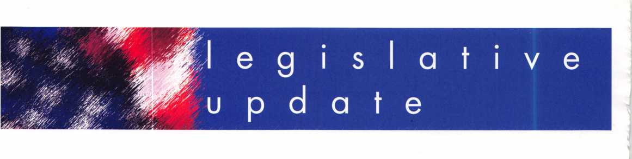

ALOA WORKING WITH C.A.R.E. FOR PASSAGE OF "THE MOTOR VEHICLE OWNERS' RIGHT TO REPAIR ACT"

The Associated Locksmiths of America, Inc. (ALOA) has joined forces with the Coalition for Auto Repair Equality (CARE) to sup­port S. 2617, " The Motor Vehicle Owner's Right to Repair Act of 2001" introduced by Sen. Paul Wellstone (D-MN) on June 13, 2002. This legislation will end the unfair monopoly by big car manufacturers to maintain control over certain service information that results in car owners often being forced to pay more and trav­el long distances for key services.

The legislation will require the Federal Trade Commission to pre­scribe and enforce rules necessary to ensure the right of a motor vehicle owner to obtain all information required for the diagnosis, service, and repair of the motor vehicle in a timely, affordable, and reliable manner. Although the bill does not specifically say what information must be provided, we are working with the after- market industry to ensure that the information you need to service any vehicle is released.

Special thanks from all locksmiths should go to Bill Neff, CML of Neff's Safe Lock & Security in Lancaster, Pennsylvania, and Tom Lynch, of Lockmaster in Nicholasville, Kentucky who took the time to travel to Washington, D.C. when the Senate bill came up before the Senate Subcommittee on Consumer Affairs, Foreign Commerce and Tourism. At that hearing, it became evident that Congress wanted this issue addressed and solved. They would like to see it done voluntarily by the auto manufacturers, but if not, then they are prepared to pass this legislation.

ALOA's position is to support the aftermarket in the passage of this bill. After it is passed, we will work with the Federal Trade Commission during the regulatory process (which comes after the bill is passed) to ensure that all locksmiths have access to this information.

With use of Immobilizer Anti Theft technology the car owner and locksmith facilities are now at the mercy of the dealer's service department. Many of the original equipment manufacturers (OEM's) have used their monopoly and blocked access to needed service tools, information, and required codes to service late

model vehicles. Today, a replacement key can cost as much as $2000, and many can only be made at a car dealership using full content service tools. Of course this can happen only during normal business hours at a location of their choosing. Plus, the consumer suffers the added expense of towing and risks transport damage to a secured vehicle as it is taken to the dealership. This results in added costs that are passed on to the consumer, and this does not include additional down time or trip interruption costs to the consumer that experiences an after hours breakdown. Many times the loss of keys comes over the weekend when many car dealerships are closed, and the consumer must wait until Monday for service.

Over ninety-percent (90%) of ALOA's members face increasing dif­ficulties in providing service to the motoring public due to the unavailability of this information from the OEM's. Currently, serv­ice information on most or all BMW, Infiniti, Jaguar, Mazda, Mercedes, Volkswagen and Volvo's is held exclusively by the OEM's and unavailable to the professional locksmith, therefore forcing the customer to return to the dealership for service.

"The Motor Vehicle Owner's Right to Repair Act seeks to remedy this situation by ensuring the motor vehicle owners or their trusted locksmith has the right to the information necessary to service his or her vehicle, at a time and place of the owners choosing. The legislation does this without requiring car manufacturers to divulge proprietary information or trade secrets," says Charles W. Gibson, Jr., CAE, Executive Director for ALOA.

S. 2617 is a companion bill to H.R. 2735 introduced by U.S. Reps. Joe Barton (R-TX) and Edolphus Towns (D-NY), in August 2001.

The Coalition for Auto Repair Equality (CARE) is a national organi­zation representing companies in the automotive after market, among them: NAPA, AutoZone, CARQUEST, Advance Auto, Jiffy Lube, O'Reilly's Auto Parts, CKS Auto Inc. (parent company of Checker, Schuck, Kragen), and Midas.

GO TO [www.aloa.org/news/legcom.cfm](http://www.aloa.org/news/legcom.cfm) AND CONTACT THE SENATE TODAY!

|  |  |
| --- | --- |
|  | NORTH CAROLINA HI552 |
| Chan | ges the locksmith licensure effective date from July 1, 2002 to January 1, 2003. |
| ST | ATUS: 08/01/2002 Signed by GOVERNOR. Session Law Number 2002-63 |
|  | A copy of this bill can be found at [www.aloa.org/news/legislation.cfm](http://www.aloa.org/news/legislation.cfm) |

Keynotes • September 2002

A PROCLAMATION

WHEREAS, locksmiths operate in the public trust as security  
professionals to secure and protect property and persons; and

WHEREAS, locks, deadbolts and other locking devices used to  
safeguard homes, businesses, and vehicles are installed, modi-  
fied and repaired by trained professional locksmiths; and

WHEREAS, as security professionals dealing with high-security  
keying systems, electronic access control systems, computerized  
systems, automobile anti-theft ignition systems, state building  
codes, life safety codes and the ADA codes, professional lock-  
smiths help ensure the safety and continued well being of the  
citizens of (name of state); and

WHEREAS, the members of the (names of all locksmith associa-  
tions in the state) are highly qualified security professionals  
engaged in consulting, sales, installation and maintenance of  
locks, keys, safes, premises security, access controls, and other  
security related endeavors; and

WHEREAS, professional locksmiths are genuinely  
associated with crime prevention and work hand in hand  
with law enforcement;

NOW, THEREFORE, I, (Governor's name), Governor of the  
State of (name of state), do hereby proclaim (date of  
recognized day) as

PROFESSIONAL LOCKSMITHS DAY

In the State of (name of state) to recognize the positive  
impact of professional locksmiths on the continued security  
of the citizens of this state.

OCTOBER IS NATIONAL CRIME PREVENTION MONTH - A GREAT TIME FOR "PROFESSIONAL LOCKSMITHS DAY"

A PROCLAMATION FROM THE STATE IS A GREAT WAY TO EDUCATE THE PUBLIC AND THE LEGISLATURE ON THE IMPOR­TANT ROLE YOU PLAY IN TODAY'S SECURITY ENVIRONMENT

October is the National Crime Prevention Council's ([www.ncpc.org](http://www.ncpc.org)) "National Crime Prevention Month." As a way to recognize this event, many ALOA Chapters, Affiliates and Locksmith Associations have become more active in getting their state to recognize "Professional Locksmiths Day" sometime dur­ing the month of October.

On Thursday, October 3rd, the Pacific Locksmith Association will be recognizing their "Professional Locksmith Day" with a banquet and speakers. The Pacific Locksmith Association repre­sents locksmiths in the Oregon and Southern Washington area, and are holding it's Pacific Locksmith Conference October 1 - 5, 2002 in Portland Oregon. This will be a wonderful way to edu­cate the public on the important role locksmiths play in today's security environment.

Many people still do not fully understand the breadth of the work locksmiths do. "Cutting keys" seem to be our pigeon-hole in life. A proclamation by the state can be a wonderful tool in marketing and promoting the profession by saying exactly what you do in each "WHEREAS". You can take that proclamation and submit it to just about any newspaper, and they will more than likely either run a story on it, or at least print the proclama­tion itself. Its better than any yellow page ad!

Also, it helps legislators understand what we do, especially in the totality of the security industry. Many times bills are intro­duced by other industries that effects locksmithing, but a state representative or senator does not understand why locksmiths should be concerned. This is because they too, do not under­stand what we do.

But where does one start? A proclamation in most states is treat­ed just like a piece of legislation. You will have to author it, hand it over to your representatives, they introduce it, its voted on and then signed by the Governor.

Here's the "How To" guide on getting a proclamation passed:

* Remember, most state legislatures only run from January to June each year, so you must get your proclamation in early (pre-filing in November or December the year before is always a good idea).
* Write the proclamation yourself (or have a committee work on it). Make sure that you are explaining all facets of what locksmiths do, and promote ALL associations in the state. Here is just one example of what you might want to say:
* Ideally you would go to your own state representative and senator to introduce the bills (in some states you only need one side to introduce it, but its always a good idea to submit them to both). Its even better if your state representative and senator are from the party in power for that branch. If not, you may want to find someone in the chapter or association who's representative or senator is a member of the party in power (it makes it easier to get on the voting calendar).
* Check in with your state representatives' and senators' office from time to time and see how the process is coming. Usually a staff person is put in charge of proclamations.
* When the proclamation is passed by the legislature, make sure you arrange to be there for the Governor's signing of it. Most states require that you go to the state capital to pick up the proclamation anyway, so make sure you get

a photo op out of it!

* NOTE: every state is different, so check with your own state representative or senator first on the proper procedure.
* Make as many copies of the proclamation as you can, and send it to every newspaper in the state asking that they let their readers know that it is "Professional Locksmiths Day."

Many chapter and association members offer special services that day including speaking at schools or neighborhood associ­ations to give a seminar on how to secure your home and busi­ness, free key cutting that day, free home security screening— the possibilities are endless!

CHECK OUT ALOA'S WEBSITE AT <http://www.aloa.org/news/legcom.cfm>

FOR THE LATEST HAPPENINGS IN YOUR STATE



Keynotes • September 2002

EMPLOYMENT

STOP LOOKING!!!!!

EXPERIENCED TECHNICIANS WANTED

Lock into your future now! If you are experienced, intelligent, and desire a secure future, come join our team. We are a full service commercial/residential security service (locks, keys, safes, cctv, access control, door related hardware). We offer: sign on bonus, top wages,company vehicle, 401k, paid vaca­tion, paid holidays, new uniforms, cross training, and job satis­faction. We are looking for the best tech's, who are ready to be treated and compensated as professionals.

Bass Security Services, Inc. • Ph#216-755-1200 ex.#128 Fax#216-755-1 220 • E-MAIL/[rmesnick@bass-security.com](mailto:rmesnick@bass-security.com)

LOCKSMITH, FULLTIME POSITION.

Southern California location, commercial/industrial work, no automotive. Earn $2,400 - 3,520 per month plus benefits. Minimum 2 years experience and clean DMV. We are a pro­fessional company specializing in commercial and industrial security. We also sell, install and service, CCTV, access con­trol, and monitored alarm systems. Please contact Dan or Curt @ 714-632-5558.

LOCKSMITH WANTED

Busy shop in Woburn, MA, has immediate opening for a self- motivated, reliable locksmith. Large customer databases for automotive, AAA, commercial and residential accounts. Applicants with own van and tools are guaranteed 50 percent commission. We can also supply van and tools. A great oppor­tunity for the right individual. All inquiries are kept strictly confi­dential. Send resume to: Locks & Keys Inc. P.O. Box 222, Woburn, MA, 01801. E-mail: [jobs@locks-keys.com](mailto:jobs@locks-keys.com). Or call John at 781/933-9999.

EXPERIENCED TECHNICIAN WANTED

Residential/Commercial/Experienced Automotive locksmith wanted. Rapidly growing, well-established Houston firm looking for good men capable of handling all types of lock work. Must have own tools and transportation. Excellent pay and other ben­efits provided. Apply at 281/497-5555 or FAX 713/975- 7534.

BUSINESS FOR SALE

Established, 30-year " award winning

" lock and safe business in rural eastern Connecticut for sale. Brisk retail store, new service vehicle, safe rigging truck and over $250,000 in equipment and inventory. This is a five-day work week business that nets the husband and wife team a nice six-figure income plus benefits. Commercial and residential only - no autos. Selling everything at a steal price of $200,000. The hard work is already done ; just take over and run. Hundreds of solid, long-established accounts, only locksmith in large area. Fax us at 860/423-5604 with your name and address and your interest. We will send you an information packet about the business, complete with photos. If you have equity, we can help with local financing.

BUSINESS FOR SALE

Well-established locksmith business in California. Grosses $140K per year. Priced at $75K. No outstanding loans on busi­ness. 80 percent income from existing accounts. Included in price: well-maintained 94 F250 Locksmith van, equipment to work out of both vans, plus furnish a separate work area and lots and lots of stock. FAX 949/458-1733 for an immediate response from us, or call Keynotes classifieds at 800/532- 2562, ext. 19, and leave your information so we can contact you. Thanks.



Classified Advertising Policy

Classified advertising space is provided free of charge to ALOA members, and fora fee of $.60 per word, $15 minimum for non-members. Classified ads may be used to advertise  
used merchandise and overstocked items for sale, "wanted to buy" items, business opportunities, employment opportunities/positions wanted and the like. Members or non-members wishing  
to advertise services or new merchandise for sale may purchase a "Commercial Classified Ad," for a fee of $1.30 per word, with a minimum of $40. Each ad will run for two issues. For blind  
boxes there is a $5 charge to members and non-members. All ads must be submitted in writing to the ALOA office by the fifteenth of the month, two months prior to issue date. Send to  
Keynotes Classifieds, 3003 Live Oak St., Dallas TX 75204-6186. ALOA reserves the right to refuse any classified advertisement that it deems inappropriate according to the stated purpose

of the classified advertising section.



Keynotes • September 2002



FOR SALE:

Mobile lock shop equipped with $4000. Write or call Anthony Rossi, 45055 East Florida Ave., Hemet, CA, 92544. Phone 909/927-6858.

WORK WANTED

SECURITY PRO FOR HIRE

CML, CPS seeks a challenging and personally rewarding position as a Locksmith at the supervisor or management level. Would prefer institution or college in the Midwest or central United States, however all locations would be con­sidered. 30+ years in the field and well versed in all aspects of sales, training and management. Please respond to the editor of ALOA, (800)532-2562, ext. 19.

WANTED TO BUY/SELL

FOR SALE:

Overstock: one llco pin kit #796-008X, $150; three Von Duprin 9927F US28 w/o trim, $300 each; eight Von Duprin 9927TP 3' 313, $450; 22 Von Duprin 88EO No trim, $200 each. Plus, used merchandise: llco model 2178U universal code machine, depth guide .015, .18, .020, .023, spacing guide .150 and .156. Cutter 20 MC, 14 MC + 1, $400. All items are plus shipping. Key machines: Sugar Model SA 400, First key — $400; Medeco manual cuts "00" commercial keys — $1500; Medeco pneumatic complete with air compressor cuts "00" commercial keys — $2000.

E-mail: [jcrenderer@aol.com](mailto:jcrenderer@aol.com), or call 305/944-0469.

FOR SALE:

Locksmith tools, code books, hardware, key blanks.

Framon, Curtis, Aero, Schlage, LSDA. For complete list, contact Gary at P.O. Box 52, Conover, Wl, 54519, phone 330/41 8-1689 or e-mail: [gary@cybertekweb.com](mailto:gary@cybertekweb.com), view complete list on web at [www.cybertekweb.com/tools](http://www.cybertekweb.com/tools).

FOR SALE

Framon Code Cutter #2, 12-volt w/Medeco head. Cutters: FC 10045-.045 flat, FC 8612 Medeco, FSS 1055 .055 slotter, FFS 1045 .045 slotter, fss 1066-.066 slotter, dial caliper, Framon space and depth book. Spacing block set for S.D. boxes F2MSDB1 (three blocks), spacing block set FSB 1001 (four blocks). $900. Shipping included.

CURTIS #14A CODE CUTTER CARRIAGES:

Ford 2, Chry3, AM2, Ford 3, Chry2, DC1, AMI, DM30, Chryl, Toy4, HD9A, Toy3, Toy2, Dyl, DMN, HD4A, GM2, GM1, HD4B, Toyl, GM2X. Cams: GM1, Chryl, Chry2, Ford3, Ford 1, Ford 2. Key gauges: GM, Ford, Chrysler, A MC, Toyota. Curtis Code books for older model: GM 1935-82, Honda Nissan, Mazda, Ford 5-pin and 10 cut, A MC, Chrysler. $400, shipping included.

Call Precision Lock Service at 330/418-1689, or e-mail to: [gary@cybertekweb.com](mailto:gary@cybertekweb.com).

FOR SALE

Abloy Key machines for sale. One brown, one blue. Also, misc. Abloy cyl., Abloy keys, Abloy parts. Medeco Sky II and Standard deadbolt, knob cyl., and misc. Make offers, whole or part. Call 561/746-6404.

WANTED TO BUY

Wanted: Original Hurd and Briggs & Stratton auto key  
blanks. I will pay $1 each. Send me a list of what you have.  
Write to: Douglas Vogel, 4779 Meadowlark Ln., Dexter, Ml,

48130.

**Magnetic Locking Systems with**

**Than Fasteners**

| ti < technical and application

assistance to system design and specification work.

DynaLock UL Listed high security products are manufactured using computerized machining centers and robotics for superior quality, tight control and timely delivery. Full, internal production capacity ensures lead time on standard products of days... not weeks. And each fully tested magnetic lock ships with a ten year warranty.

Standard maglocks, Passive Infrared, Delayed Egress and Low Profile DynaLock systems offer holding forces from 650 to 1500 lbs. Accessory products include UL listed power supplies, keypad systems, keyswitches, exit controls, timers, monitor stations and custom consoles.

Don’t settle for just a lock... Get more than maglocks with DynaLock.

Call today:

**877-DYNALOCK**

**(877-396-2562)**

or visit:

dynalock.com

***Electromagnetic Locking Systems***

As seen at the ALOA show.

DynaLock Corporation

705 Emmett Street, P.O. Box 2728 Bristol, CT 06011-2728 Fax: 860/585-0338 [info@dynalock.com](mailto:info@dynalock.com)



Keynotes • September 2002

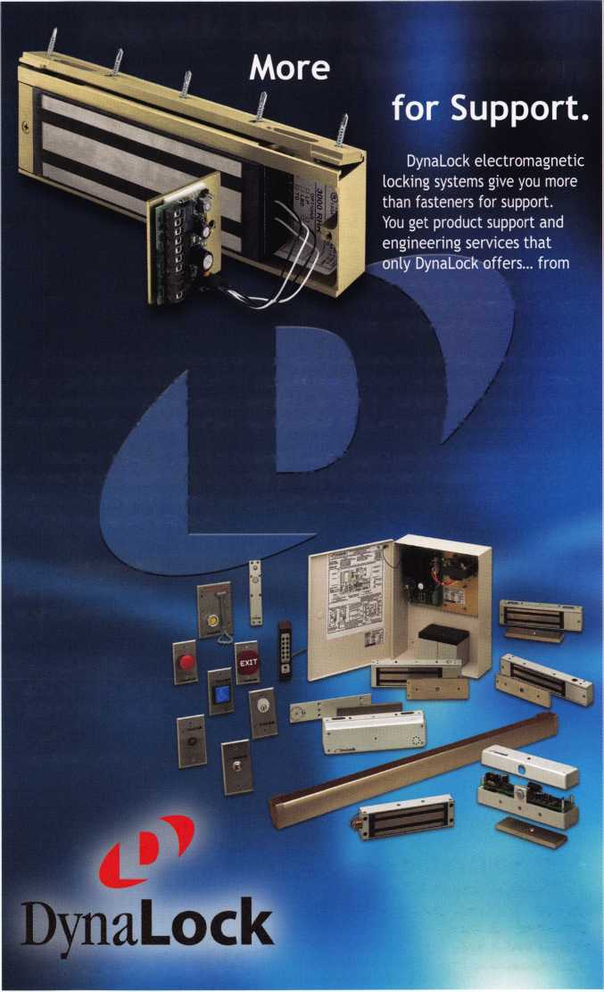

Distributor

ADI Inc.

Phone: 631-692-1000 Fax: 631-692-301 1

Accredited Lock Supply Co.

Phone: 201-865-5015 Fax: 201-865-0030 [www.acclock.com](http://www.acclock.com)

Ace Lock & Security Supply

Phone: 908-688-7666 Fax: 908-688-2442 [www.acelock.com](http://www.acelock.com)

Action Hardware Inc.

Phone: 800-662-6695 Fax: 800-930-2329

Andrews Wholesale Lock Supply

Phone: 717-272-7422 Fax: 717-274-8659

Boyle & Chase Inc.

Phone: 800-325-2530 Fax: 800-205-3500 [www.boyleandchase.com](http://www.boyleandchase.com)

Clark Security Products

Phone: 800-854-2088 Fax: 619-974-5284 [www.clarksecurity.com](http://www.clarksecurity.com)

Cook's Building Specialties

Phone: 505-883-5701 Fax: 505-883-5704

Dire's Lock & Key Company

Phone: 303-294-0176 Fax: 303-294-0198

Direct Security Supply, Inc.

Phone: 800-252-5757 Fax: 800-452-8600

Doyle Security Products

Phone: 800-333-6953 Fax: 612-521-0166 [www.doylesecurity.com](http://www.doylesecurity.com)

Dugmore and Duncan, Inc.

Phone: 888-384-6673 Fax: 888-329-3846

E. L. Reinhardt Co., Inc.

Phone: 800-328-131 1 Fax: 651-481-0166 [www.elreinhardt.com](http://www.elreinhardt.com)

Ewert Wholesale Hardware

Phone: 800-451-0200 Fax: 708-597-0881

42

|  |  |  |  |  |  |
| --- | --- | --- | --- | --- | --- |
| 4f!  ^ i | PH  ) | ass | O C | i a 1 | ■ e |
| k | t \ | m | e m b | e r s |  |

Fairway Supply, Inc.

Phone: 214-350-0021 Fax: 214-352-4299

[www.fairwaysupply.com](http://www.fairwaysupply.com)

Foley-Belsaw

Company

Phone: 800-821-3452 Fax: 816-483-5010

[www.belsaw.com](http://www.belsaw.com)

Fried Brothers Inc.

Phone: 800-523-2924

Fax:215-592-1255

[www.fbisecurity.com](http://www.fbisecurity.com)

H L Flake Co.

Phone: 800-231-4105 Fax: 713-926-3399 [www.hlflake.com](http://www.hlflake.com)

H.S. & S.

Wholesale Distrib.

Phone: 313-342-6777 Fax: 313-342-7580

Hans Johnsen Company

Phone: 214-879-1550 Fax: 214-879-1530

Hardware Agencies, Ltd.

Phone: 416-462-1921 Howard Keys Phone: 704-509-4944 Fax: 704-509-6248 www. howa rdkeys .com IDN Incorporated Phone: 817-421-5470 Fax: 817-421-5468 Intermountain Lock & Supply Phone: 800-453-5386 Fax: 801-485-7205

[www.intermountainlock.com](http://www.intermountainlock.com)

Jo Van Distributors

Phone: 416-752-2238 Fax:416-752-7282

Lockmasters, Inc.

Phone: 859-885-6041 Fax: 859-885-7093

[www.lockmasters.com](http://www.lockmasters.com)

Locks Company

Phone: 800-288-0801 Fax: 305-949-3619

M. Zion Company

Phone: 212-349-8677 Fax: 212-964-0495

Massglass & Door Service

Phone: 888-742-8837 Fax: 818-991-5742

[www.massglass.com](http://www.massglass.com)

McDonald Dash Locksmith Supply

Phone: 800-238-7541 Fax: 901-366-0005

[www.mcdonalddash.com](http://www.mcdonalddash.com)

McManus Locksmith Supply, Inc.

Phone: 704-333-9112 Fax: 704-332-8664

Monaco Lock Co.

Phone: 800-526-6094 Fax: 800-845-5625 [www.monacolock.com](http://www.monacolock.com)

Omaha Wholesale Hardware

Phone: 800-238-4566 Fax: 402-444-1664 [www.omahawh.com](http://www.omahawh.com)

Phoenix Safe International LLC

Phone: 765-483-0954 Fax: 765-483-0962 [www.phoenixsafeusa.com](http://www.phoenixsafeusa.com)

SecureRite.Com

Phone: 800-241-3930 Fax: 858-974-5269 [www.SecureRite.Corn](http://www.SecureRite.Corn)

Sentry Security Fasteners

Phone: 309-693-2800 Fax: 800-693-2872

Somerset Security Products

Phone: 800-881-5206 Fax: 800-206-9949

Southern Lock and Supply Co.

Phone: 727-541-5536 Fax: 727-544-8278 southernlock.com

Stone & Berg Wholesale

Phone: 800-225-7405 Fax: 800-535-5625

Taylor Security & Lock

Phone: 301-948-7670 Fax: 301-948-1029 [www.taylorsecurity.com](http://www.taylorsecurity.com)

The Locksmith Store Inc.

Phone: 847-364-5111 Fax: 847-364-5125 [www.locksmithstore.com](http://www.locksmithstore.com)

Timemaster Inc.

Phone: 888-798-8465 Fax: 800-798-8463 [www.time-master.com](http://www.time-master.com)

Top Notch Distributors, Inc.

Phone: 800-233-4210 Fax: 800-854-4146 [www.4topnotch.com](http://www.4topnotch.com)

U.S. Lock Corp.

Phone: 800-925-5000 Fax: 800-338-5625 [www.uslock.com](http://www.uslock.com)

Webster Safe &

Lock Co., Inc.

Phone: 901-332-2911 Fax: 901-332-2878 webstersinc.com

Manufacturer

A & B Safe Corporation

Phone: 800-253-1267 Fax: 856-863-1208 [www.a-bsafecorp.com](http://www.a-bsafecorp.com)

ABUS Lock Company

Phone: 800-352-2287 Fax: 602-595-3499 [www.abus.com](http://www.abus.com)

Abloy Door Security

Phone: 800-465-5761 Fax: 514-335-0430 [www.abloy.com](http://www.abloy.com)

Adams Rite Mfg. Company

Phone: 800-872-3267 Fax: 800-232-7329 [www.adamsrite.com](http://www.adamsrite.com)

Adesco Safe Mfg. Company

Phone: 800-821-6803 Fax: 562-408-6427 [www.adesco.com](http://www.adesco.com)

Adrian Steel Company

Phone: 800-677-2726 Fax: 517-265-5834 [www.adriansteel.com](http://www.adriansteel.com)

Alarm Lock Systems Inc.

Phone: 800-252-5625

Fax:516-789-3383

[www.alarmlock.com](http://www.alarmlock.com)

All Five Tool Company, Inc.

Phone: 860-583-1691 Fax: 860-583-4516 [www.all5tool.com](http://www.all5tool.com)

American Lock Company

Phone: 708-534-2000 Fax: 708-534-0531

American Security Products

Phone: 909-685-9680 XI083

Fax: 909-685-9685 [www.amsecusa.com](http://www.amsecusa.com)

BWD Automotive

Phone: 334-872-6524 Fax: 334-874-601 1 [www.bwdautomotive.com](http://www.bwdautomotive.com)

Baldwin Hardware

Phone: 610-796-4012 Fax: 610-796-4493

Be-Tech Security Systems Ltd.

Phone: 852-231-67447 [www.be-tech.com.hk](http://www.be-tech.com.hk)

Buddy Products

Phone: 800-886-8688 Fax: 312-733-8356 [www.buddyontheweb.com](http://www.buddyontheweb.com)

COMPX Security Products

Phone: 864-297-6655 Fax: 864-297-9987 [www.nclnet.com](http://www.nclnet.com)

Curtis Industries,

A Barnes Distr.

Phone: 800-555-5397 Fax: 800-867-6020 [www.curtisindustries.com](http://www.curtisindustries.com)

DETEX Corporation

Phone: 800-729-3839 Fax: 830-620-6711

DORMA Architectur­al Hardware

Phone: 717-336-3881 Fax: 717-336-3500 [www.dorma-usa.com](http://www.dorma-usa.com)

Don-Jo Manufactur­ing, Inc.

Phone: 978-422-3213 Fax: 978-422-3467 [www.don-jo.com](http://www.don-jo.com)

Door Controls Inter­national

Phone: 800-742-3634 Fax: 800-742-0410 [www.doorcontrols.com](http://www.doorcontrols.com)

ESP Lock Products Inc.

Phone: 978-562-3481 Fax: 978-562-9859

FireKing Security Products

Phone: 800-457-2424 Fax: 800-896-6606 [www.fireking.com](http://www.fireking.com)

HES, Inc.

Phone: 623-582-4626 Fax: 623-582-4641 [www.hesinnovations.com](http://www.hesinnovations.com)

HPC, Inc.

Phone: 847-67]-6280 Fax: 847-671-6343 [www.hpcworld.com](http://www.hpcworld.com)

Hongtai Lock Co. Ltd.

Phone: 137-238-1414 Fax: 208-793-3856

INTELLIKEY Corp.

Phone: 800-226-0703 Fax: 321-724-081 1 [www.intellikey.com](http://www.intellikey.com)

llco Unican

Phone: 252-446-3321 Fax: 252-446-4702 [www.kaba-ilco.com](http://www.kaba-ilco.com)

Jet Hardware Mfg., Co.

Phone: 718-257-9600 Fax: 718-257-0973

KABA High Security Locks

Phone: 860-621-3601 Fax: 860-621-9727 [www.kabausa.com](http://www.kabausa.com)

KEY-BAK/West Coast Chain Mfg.

Phone: 909-923-7800 Fax: 909-923-0024 [www.keybak.com](http://www.keybak.com)

Keri Systems Inc.

Phone: 408-451-2520 Fax: 408-441-0309 [www.kerisys.com](http://www.kerisys.com)

Knaack Manufactur­ing Co.

Phone: 800-456-7865 Fax: 815-459-9097 [www.weatherguard.com](http://www.weatherguard.com)

LAB Security

Phone: 800-243-8242 Fax: 860-583-7838 [www.labpins.com](http://www.labpins.com)

LCN Closers/Div of Ingersoll

Phone: 815-875-3311 Fax: 815-879-1497 [www.lcnclosers.com](http://www.lcnclosers.com)

La Gard Inc.

Phone: 310-325-5670 Fax: 310-325-5615 [www.lagard.com](http://www.lagard.com)

Locksmith Ledger International

Phone: 770-886-0800 Fax: 770-889-7703 lledger.com

Lucky Line Products, Inc.

Phone: 858-549-6699 Fax: 858-549-3241

M.A.G. Security

Phone: 714-891-5100 Fax: 7] 4-892-6845 [www.magsecurity.com](http://www.magsecurity.com)

**marks, u.s.a.**

Phone: 516-225-5400 Fax: 516-225-6136 [www.marksusa.com](http://www.marksusa.com)

Keynotes • September 2002



MARRAY

ENTERPRISES

Phone: 408-970-0213 Fax: 408-970-8767 [www.marray.com](http://www.marray.com)

MCS Communica­tion Systems

Phone: 514-444-2040 Fax: 514-444-2029 www. mcscom m u n ica- tion.com

MMD, Inc.

Phone: 865-428-3611 Fax: 865-453-4136

MUL-T-LOCK USA, Inc.

Phone: 800-562-351 1 Fax: 973-778-4007

[www.mul-t-lock.com](http://www.mul-t-lock.com)

Master Lock Company

Phone: 414-444-2800 Fax: 414-444-0322 [www.masterlock.com](http://www.masterlock.com)

Medeco Security Locks

Phone: 540-380-5000 Fax: 540-380-5010 [www.medeco.com](http://www.medeco.com)

NKL Industries Inc.

Phone: 800-528-9900 Fax: 757-485-0271 [www.nklindustries.com/](http://www.nklindustries.com/) products_NK

Pro Steel

Phone: 801-373-2385 Fax: 801-373-2399 [www.pro-steel.net](http://www.pro-steel.net)

ROFU International Corp.

Phone: 800-255-7638 Fax: 253-922-1728 [www.rofu.com](http://www.rofu.com)

Rutherford Controls Int'l. Co.

Phone: 757-427-1230 Fax: 757-427-9549 [www.rutherfordcontrols.c](http://www.rutherfordcontrols.c) om

STRATTEC Security Corp.

Phone: 414-247-3415 Fax: 414-247-3692

Sargent & Greenleaf, Inc.

Phone: 859-885-941 1 Fax: 859-885-3063 [www.sglocks.com](http://www.sglocks.com)

Sargent Manufac­turing Co.

Phone: 203-562-2151 Fax: 203-776-5992

Schlage Lock Co.

Phone: 719-264-5300 Fax: 719-264-5382 [www.schlagelock.com](http://www.schlagelock.com)

Schwab Corp.

Phone: 765-447-9470 Fax: 765-447-8278 www. schwa bcorp .com

Securitron Magnalock Corp.

Phone: 775-355-5626 Fax: 775-355-5636 [www.securitron.com](http://www.securitron.com)

Security Door Controls

Phone: 805-494-0622 Fax: 805-494-8861 [www.sdcsecurity.com](http://www.sdcsecurity.com)

Security Solutions

Phone: 405-376-1600 Fax: 405-376-6870

Sentry Group

Phone: 716-381-4900 Fax: 716-381-8559 [www.sentrysafe.com](http://www.sentrysafe.com)

Sully Tools Inc.

Phone: 703-689-3416 Fax: 703-787-0869 [www.sullytools.com](http://www.sullytools.com)

SunSafes Manu­facturing Co.

Phone: 823-194-59300 Fax: 823-194-59400 [www.eaglesafes.com](http://www.eaglesafes.com)

Taymor Industries, Inc.

Phone: 800-388-9887 Fax: 800-288-8133

Trine Access Tech­nology

Phone: 718-829-2332 Fax: 718-829-6405 [www.trineonline.com](http://www.trineonline.com)

Videx Inc.

Phone: 541-758-0521 Fax: 541-752-5285

[www.videx.com](http://www.videx.com)

W-LOK

Corporation

Phone: 616-355-4015 Fax: 616-355-4295 [www.wlokcorp.com](http://www.wlokcorp.com)

Yale Security Group, Inc.

Phone: 800-438-1951 Fax: 800-338-0965

Service

Organization

1 -800 Locksmith 1994 Inc.

Phone: 800-562-5764 Fax: 718-236-4504 www. 1 800locksmith.net

Allstate Insurance Company

Phone: 847-402-8196 Fax: 847-326-7509 [www.allstate.com](http://www.allstate.com)

Emergency Road Service Inc.

Phone: 888-839-5386 Fax: 678-277-8105

Professional Business Products

Phone: 800-258-6219 Fax: 813-888-5393

The National Locksmith

Phone: 630-837-2044 Fax: 630-837-1210 [www.thenationallock- smith.com](http://www.thenationallock-smith.com)

Upcoming Classes

Sept. 25-27, 2002

SERLAC Trade Show

Orlando, Florida

Michael Belden, CRL, CPS: 904/396-2022  
INVESTIGATIVE LOCKSMITHING I, II, & 111(3 DAYS)  
COMPREHENSIVE ACCESS CONTROL (2 DAYS)  
MOTORCYCLE LOCKSMITHING  
ADVANCED AUTOMOTIVE

***DICATION***



Keynotes • September 2002

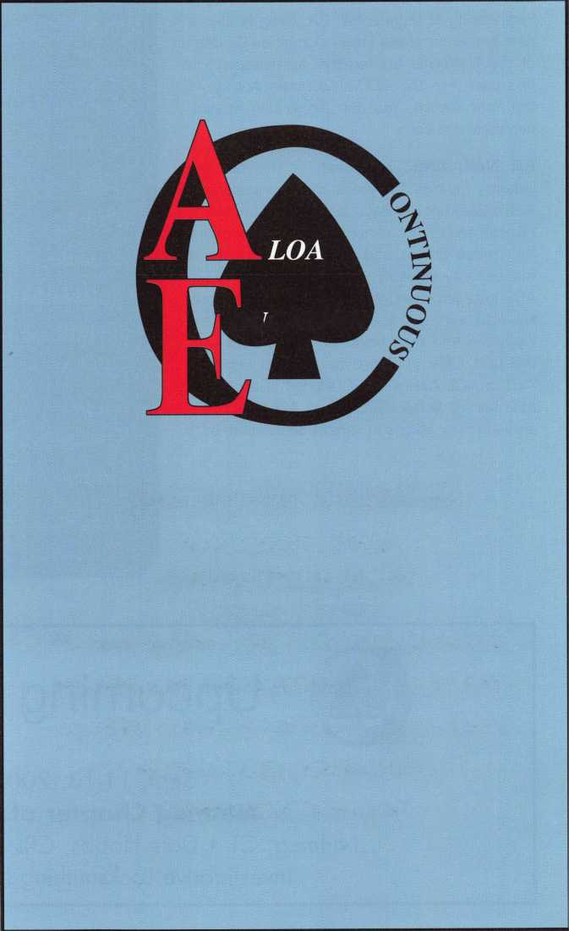

back page

About the Authors

Gordon Malczewski is a product manager for Medeco.

Jim DeSimone is editor of Keynotes.

Greg Perry, CML, CPS has been in the lock­smith industry for 20 years. He's spent half of that time as a field technician for Security Engineering in Ridgecrest, CA. Greg is also a past president of the Desert Counties Chapter of the California Locksmiths Association. He has also won the 2002 Keynotes Author of the Year Award. You can e-mail him at [glm- perry@iwvisp.com](mailto:glm-perry@iwvisp.com).

Bill Neff, CML, has been in the security industry for over 25 years and is president of Neffs Safe Lock & Security, Inc., in Lancaster, PA. Bill has taught various classes throughout the United States and abroad to students in the security industry. He is a certified ALOA ACE instructor and Mas Hamilton instructor. He also serves as a contributing editor for Keynotes and the Locksmith Ledger. Bill was the first CML in Pennsylvania, and received ALOA’s ACE Award in 2000. Bill is an active member of ALOA, GPLA, and ASIS, and has served many offices in various associations.

|  |  |
| --- | --- |
| r |  |
| Ad Index | |
| Strattec Inside Front Cover | |
| Stam Insight | 5 |
| Fox Valley Technical College .. | 7 |
| W-LOK | 8 |
| PLA | 9 |
| Safetech | 11 |
| LP International | 19 |
| Yale | 27 |
| Aable | 29 |
| Yankee Security Conference | 35 |
| Professional Business Products. | 37 |
| Dynalock | 41 |
| SERLAC | 43 |
| Nutmeg | |
| Chapter of ALOA | ...Back Page |
| Sanzo Specialties Inside Back Cover | |
| Hickok | Back Cover |
| L | A |



Upcoming Classes

Sept. 11-13, 2002

Nutmeg Chapter of ALOA

Nutmeg, CT • Dale Hobbs, CRL: 203/237-4602  
Investigative Locksmithing I, II, and III

Keynotes • September 2002

reacts **LOCKSMITH Professionals**

**AD / ID KEY TAGS**

Specifically designed to identify the product you work with daily and promote your business with your custom Ad copy.

back side of tag with 4 lines for key identification

KEYS FOR

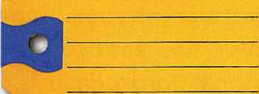

**SANZO-ENDtCOTT.NY 13760**

**Clear Plastic Protective Sleeves** Stock#PPS10

Protect your key tags with * 100 200 500 1000

durable plastic sleeves 11.50 19.95 42.00 68.50

**TO ORDER:** Choose QTY., Key Tags with Chains or Rings, TAG COLOR and Provide Imprint Copy (printed black only).

**Key Tag Envelopes**

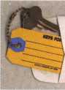

ANDOVER LOCK & KEY SERVICE

3221 LAKESIDE HWY.  
ANDOVER MA 05242  
(508) 626-1 111

**FREE Printing of Your Ad Copy on bac**

Choose from Brass Plated Bead Chains or Chrome Plated Wire Rings

LAKE VIEW ■

LOCKSMITH **m.**

24 Hour Service a Ji^SSH **(845) 556-LOCK**

Stock # KTE3 Actual Size: 2Vfe" x 4W Added security and finishing touch when presenting keys to your customers

* 100 200 500 1000

10.50 17.00 37.50 65.00

QUANTITIES100 200 500 1000 2000 3000 5000

**it** KEY TAGS with CHAINS or RINGS 32.00 42.95 83.95 115.00 195.00 269.00 395.00

YOUR CHOICE OF CHAINS OR RINGS - IF NOT SPECIFIED WE SHIP CHAINS

**Key Tags Only (no chains or rings)** - Deduct 10% from above prices National Logos - No Charge / Custom Logos > Add $25.00 and supply clean B & W artwork

**TRANSPARENT PLASTIC KEY TAGS Stock # DP-226 Actual Size: 2" x 1.375**

Available colors: Blue,

Amber or Crystal  
•Extra heavy beadchain  
• “Lifetime” unbreakable  
proponate •Insert card is  
printed with your Ad Copy  
• Handy identification space  
on reverse side

**\*50** 49.50 100 82.95

1. .. 112.50 250....142.50
2. .. 195.50 1000...346.50

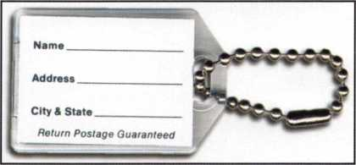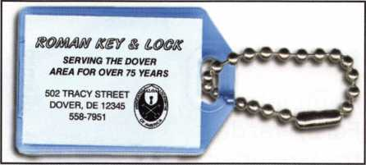

**FULL COLOR PHOTO BUSINESS CARDS**

In an effort to make buying full color more economical we have  
introduced the lowest quantity in the industry just 250 cards, now  
you can have high quality full color cards at unbelievable low  
prices! Our new digital full color press makes this possible.

Choose from the Antique Lock design # FCBC-121 or  
Mountain Creek design #FCBC-10 shown or if you have  
your own design send in a sample, we will duplicate it for  
a one time $25.00 setup charge.

TO ORDER: send in the copy you need, along with your  
photo and we will fit the copy best to suit the design  
you choose. Specify card stock.

*Choose from 2 finishes of high quality heavy card stock*

Available imprint colors: Black, Medium  
Blue, Dark Blue, Red, Purple, Golden  
Yellow, Medium Green, Dark Green,  
Brown, Pink and Orange - if not specified  
we print as shown in sample design. For  
Multiple Color Imprint - indicate color of  
each line and/or logo color  
(National Logos - FREE  
Custom Logos - $25.00)

**\* QTY. 250 500**

**Matte 54.95 82.50**

High Gloss 63.75 91.50

each additional

1000 iooo

**96.50 89.00/M**

104.95 98.00/M

**FREE PHOTOS - your cards can be ordered with or without photo**

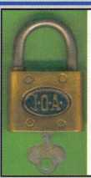

**Tom Carter**

**Licensed Master Locksmith**

3221 Lakeside Hwy. Andover, MA 05242

508-626-1 111

**ANDOVER**

**LOCK & KEY SERVICE**

*“Andover’s* #7 *Locksmith Since 1947”*

**24 HOUR EMERGENCY SERVICE**



**Tom Carter**

Licensed Master Locksmith

**ANDOVER**

**LOCK & KEY SERVICE**

€ *f.locksmith Since 1947"*

**- ^WdlltfOlERGENCY SERVICE**

mdover, MA 05242

3221*b

**\*$7.00 SHIPPING CHARGE ADDED PER ORDER**

**SANZO SPECIALTIES, INC. BOX 68 ENDICOTT, NY 13760  
TOLL FREE: 1-800-222-4041 FAX: 607-748-0507**

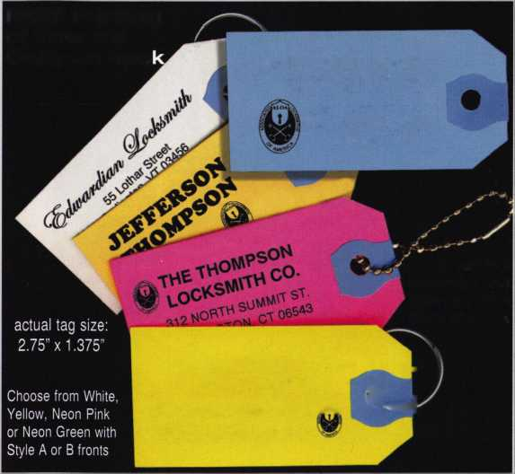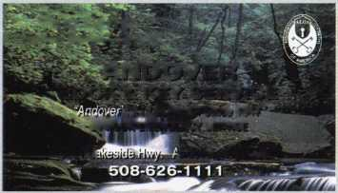

**You're never on your own..**

**Toll Free Tech Support**

**1**-**800**-**342-5080**

"I've lost my Taurus keys.»

# ..

can you make a new set?"

How much of your money  
have you sent to the

W

local Ford dealer?

8008LA New Generation STAR

Use the Ford factory tool to  
program transponder keys for  
ALL Ford/Mazda vehicles.

Keep the money in your pocket!

NGS

Complete

Ford/Mazda

transponder

coverage

PLUS the

ability to  
clear ALL

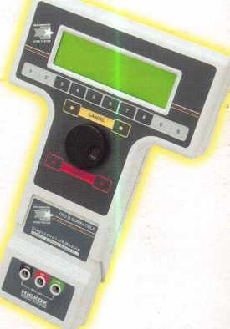

Diagnostic

Service Codes

Say "YES" to  
$100 phone calls



HICKOK

INCORPORATED

